**SUSTAINABLE OUTREACH AND UNIVERSAL LEADERSHIP LIMITED  
(SOUL)**



**STUDENT LIFE CYCLE MANAGEMENT**

**GAP ANALYSIS DOCUMENT**

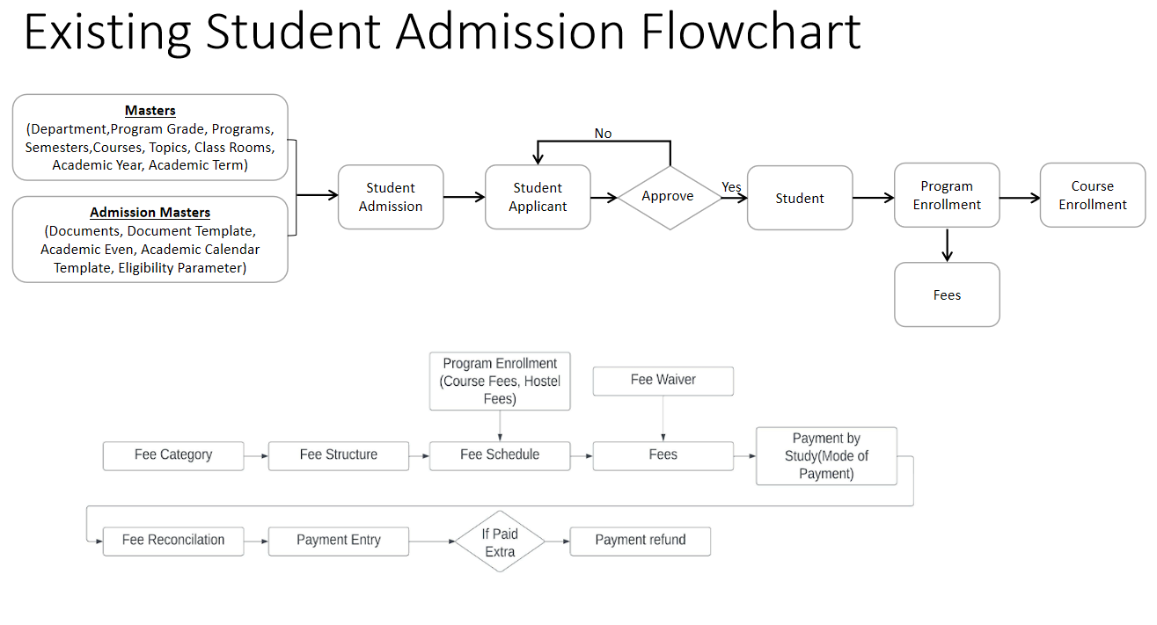

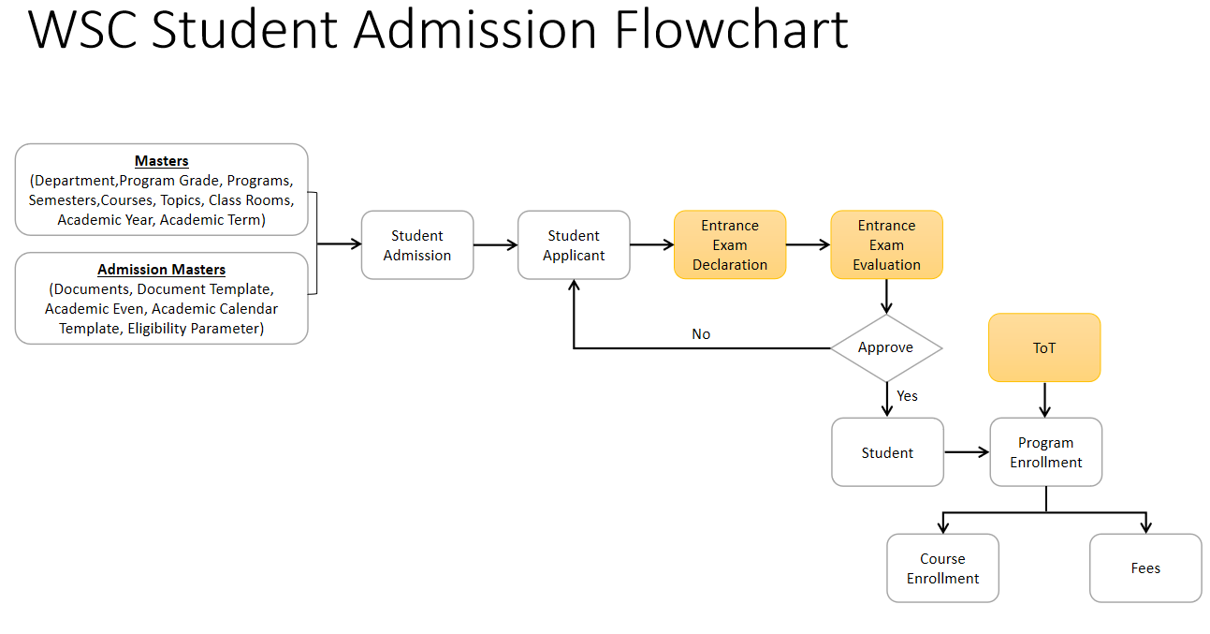

# **Admission**

## **Masters**

### **1.1Department**

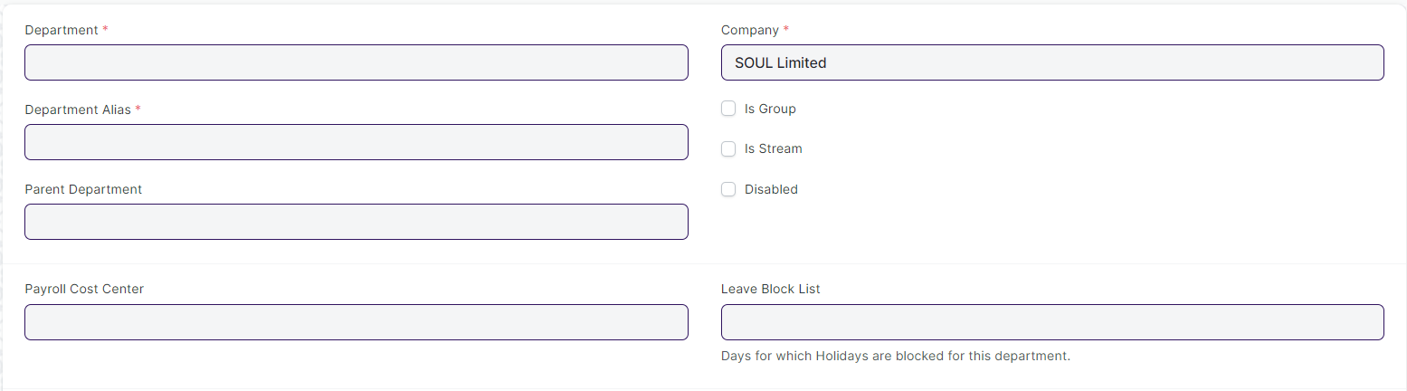

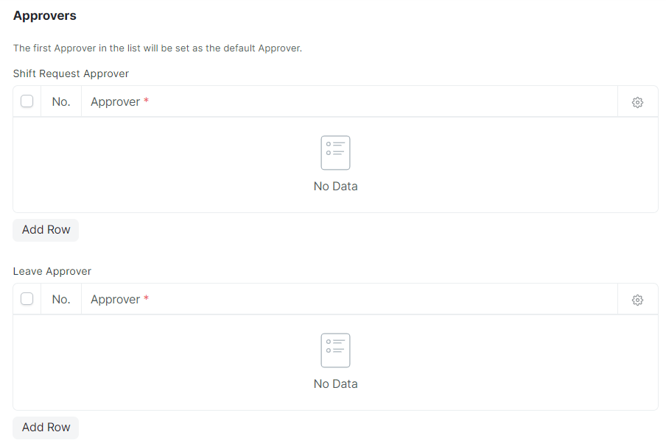

#### **Business Requirements:**

* No changes needed as discussed.

### **1.2 Program Grades**

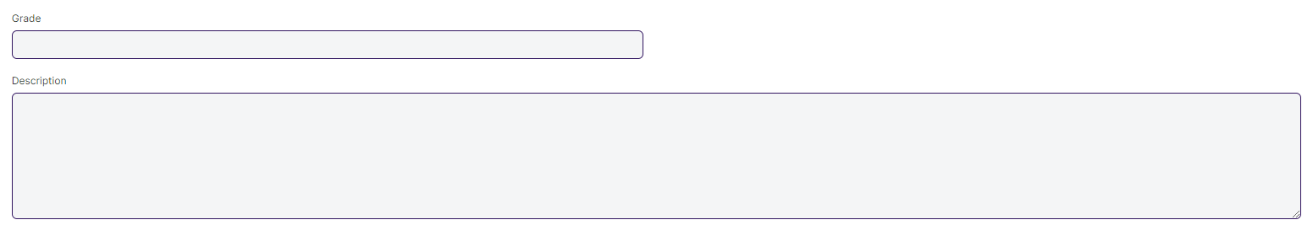

#### **Business Requirements:**

* Change the name of Program Grades to Course Grade.

### **Programs**

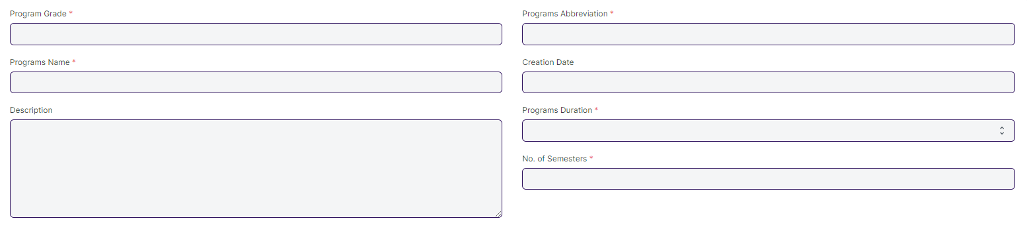

#### **Business Requirements:**

* The following name will be change:

1. Programs to Course
2. Program Grades to Course Grade
3. Programs Name to Course Name
4. Programs Duration to Course Duration

### **Semester**

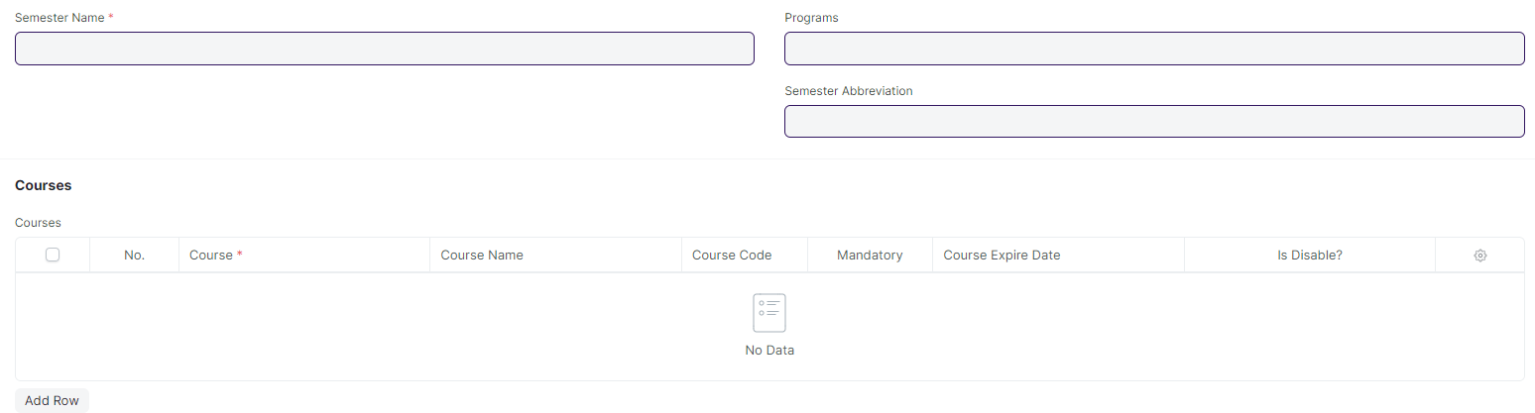

#### **Business Requirements:**

* No changes needed as discussed.

### **Courses**

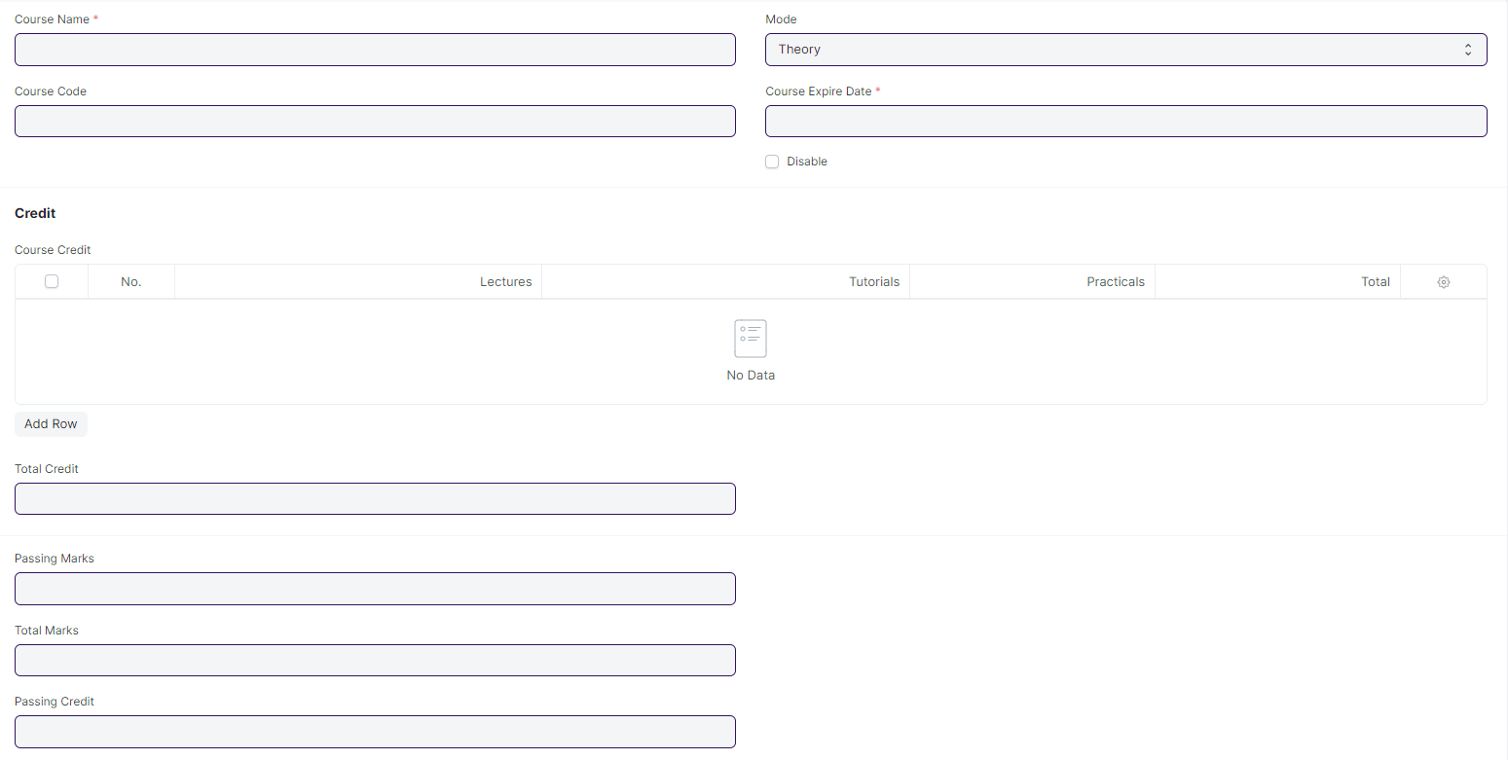

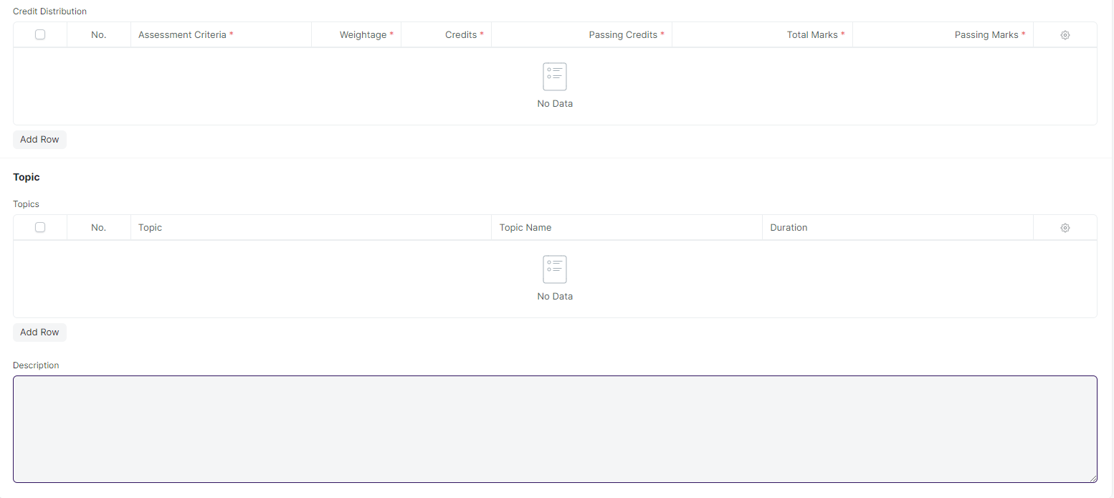

#### **Business Requirements:**

* The following name will be change:

1. Courses to Modules
2. Course Name to Module Name
3. Course Code to Module Code
4. Course Expire Date to Module Expire Date
5. Course Credit to Module Credit

* A workflow of approval or rejection needs to be added to the course screen, so that only the admin can add the course to the course master and the specific semester.
* Workflow Actions:

1. Approve
2. Reject

* In Course screen's Topic table needs to be expanded to include the topic description field and a button for attaching the lesson plan.
* In Topic Table following fields need to be added:

1. Topic Description.
2. Attach field for uploading the lesson plan.

* The Passing Credit field should be remove/hidden in the course screen.

### **Academic Year**

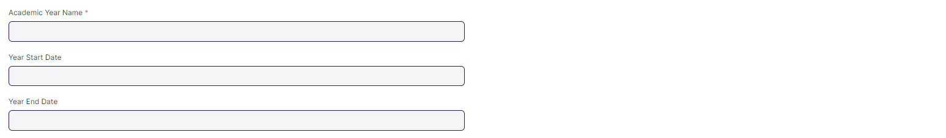

#### **Business Requirements:**

* No changes needed as discussed.

### **Academic Term**

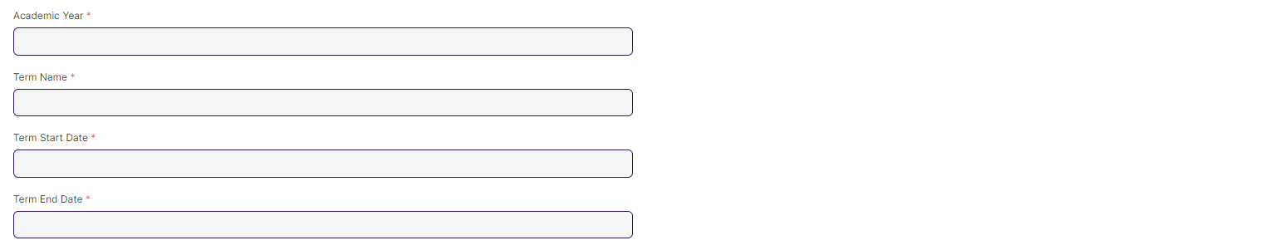

#### **Business Requirements:**

* No changes needed as discussed.

#### **Room****Business Requirements:**

* No changes needed as discussed.

## **Student And Instructor**

### **Student**

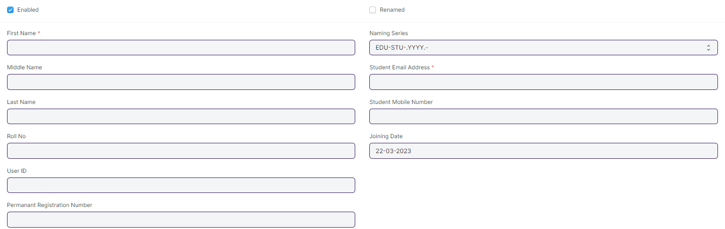

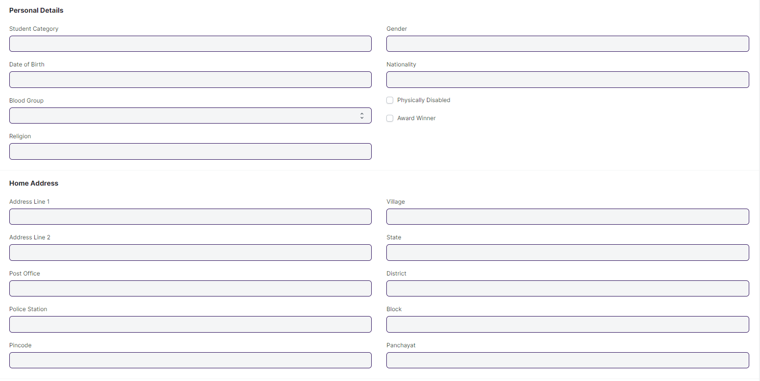

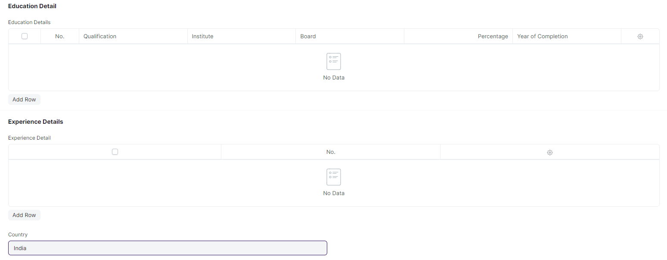

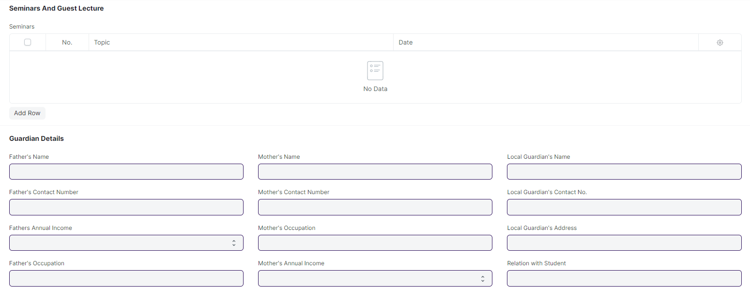

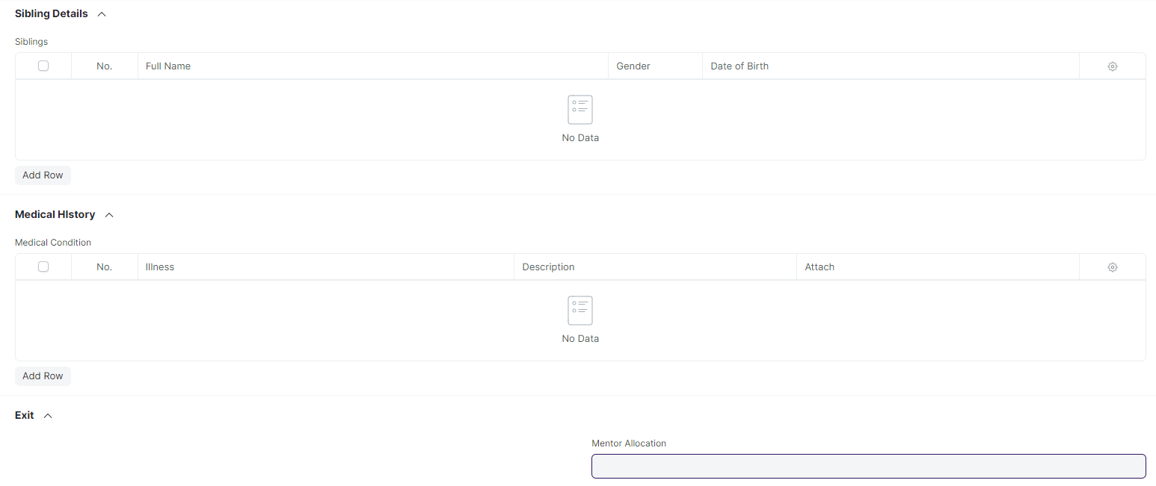

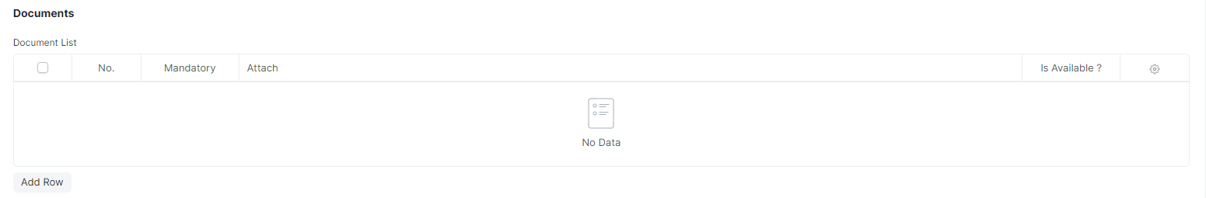

#### **Business Requirements:**

* No changes needed as discussed.

### **Instructor**

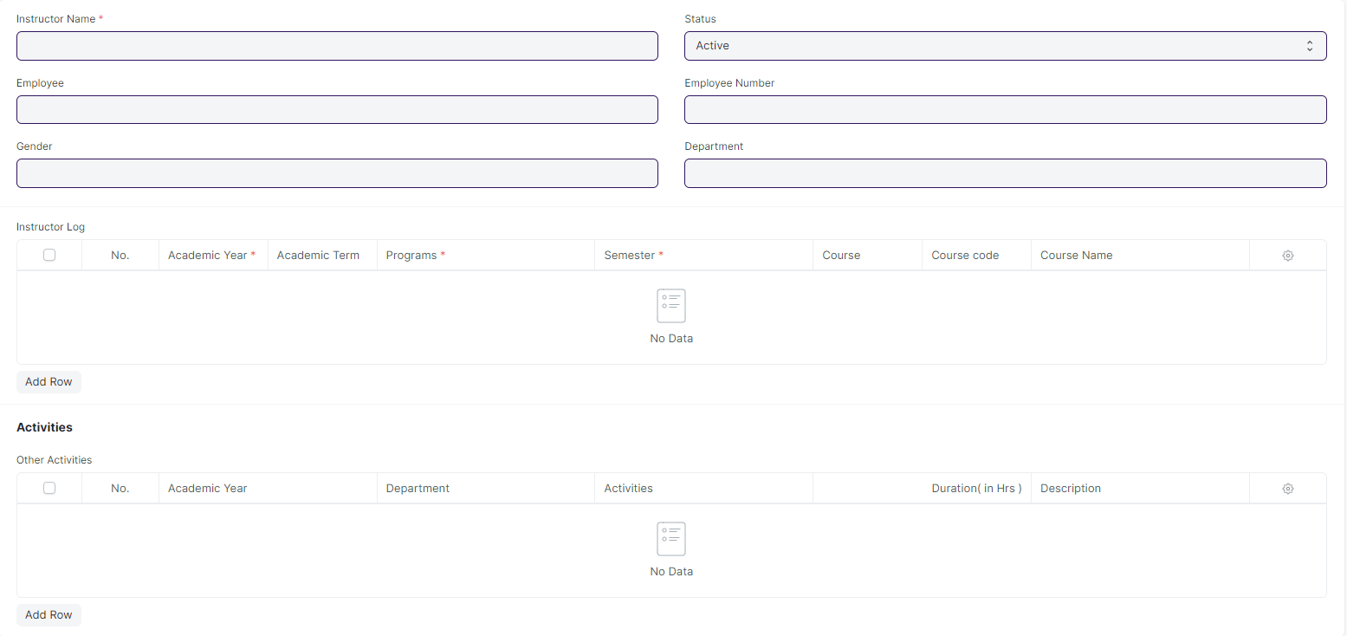

#### **Business Requirements:**

* No changes needed as discussed.

### **Student Category**

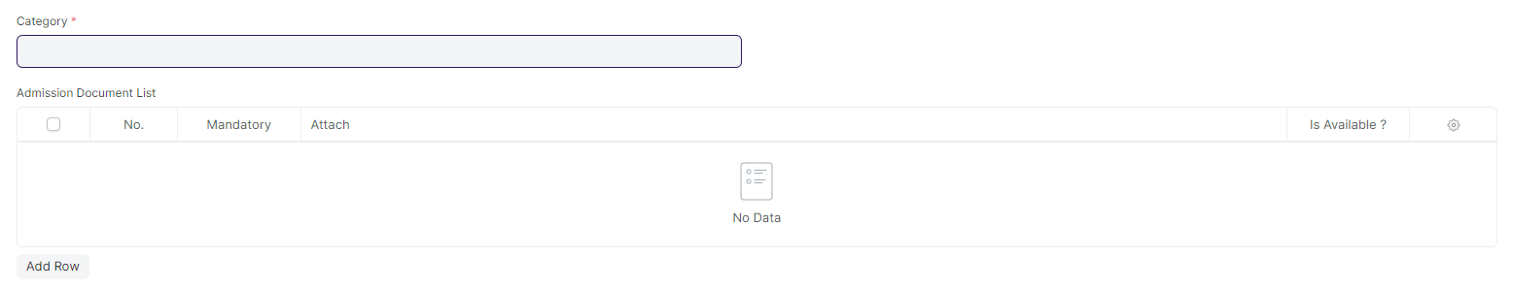

#### **Business Requirements:**

* No changes needed as discussed.

### **Student Batch Name**



#### **Business Requirements:**

* No changes needed as discussed.

## **Admission Master**

### **Academic Events**



#### **Business Requirements:**

* No changes needed as discussed.

### **Academic Calender Template**

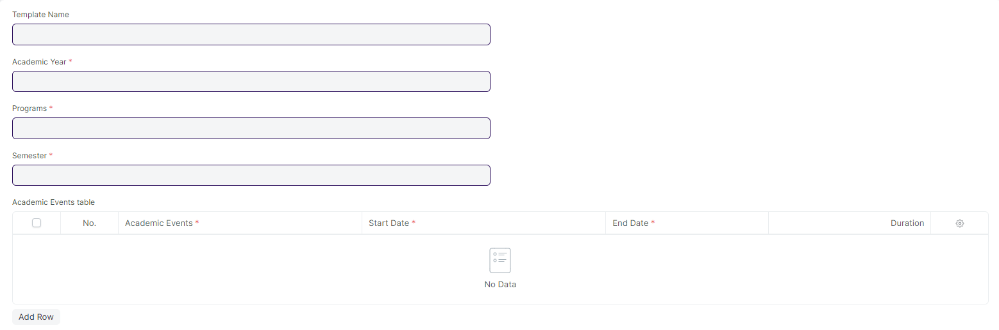

#### **Business Requirements:**

* Different Academic Events, such as Exam Dates, other academic events, and TOT events, should be displayed in a calendar view.

### **Eligibility Parameter**



#### **Business Requirements:**

* An age criteria should be added as an eligibility criterion.

### **Documents Template**

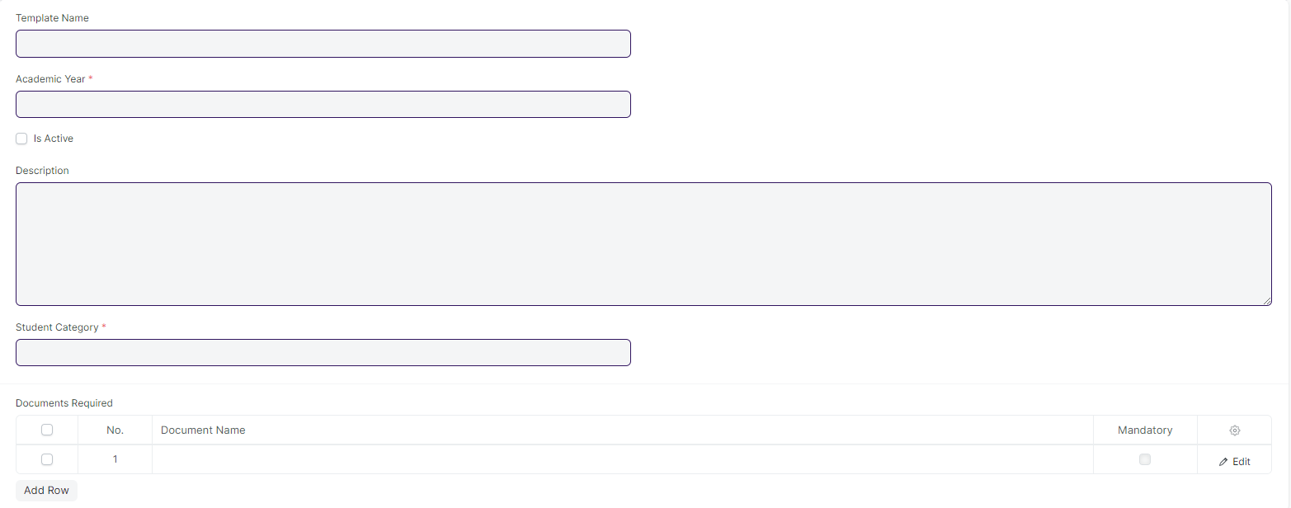

#### **Business Requirements:**

* No changes needed as discussed.

## **Application and Enrollment**

### **Student Admission**

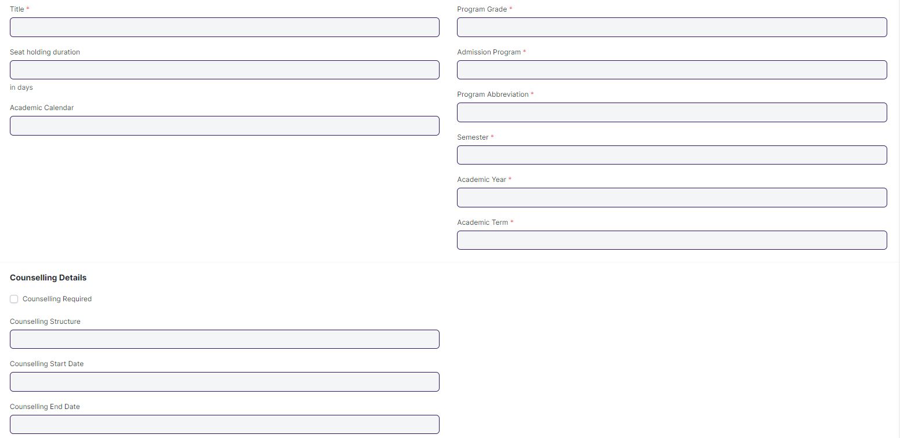

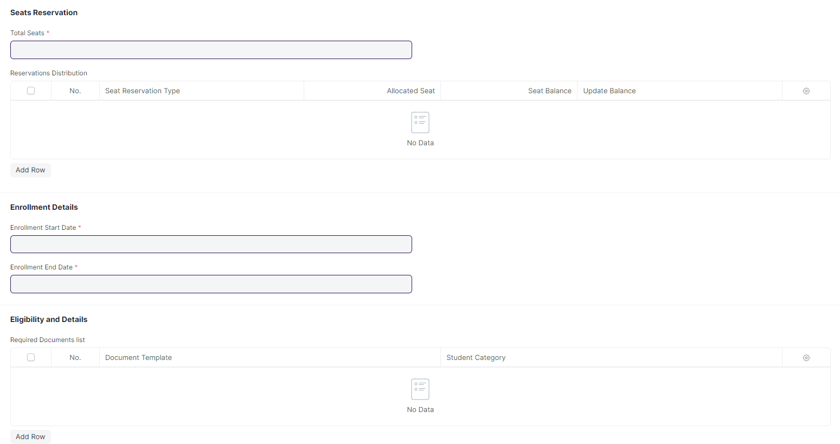

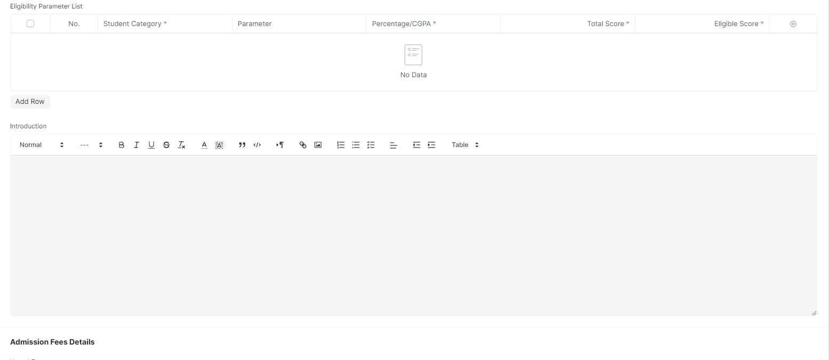

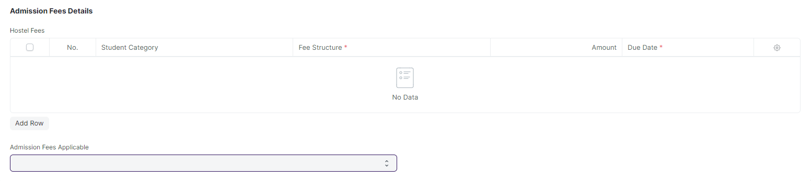

#### **Business Requirements:**

* The following name will be change:

1. Program Grade to Course Grade
2. Admission Program to Admission Course
3. Program Abbreviation to Course Abbreviation

* The age criteria field needs to be added.
* A student who applied and appeared for the entrance exam was selected for counselling but did not choose any course offered then he/she will be rejected.
* If there are still seats available at WSC, they will advertise for Spot Admission, which will allow both new and previously selected students to visit the WSC center to directly apply for admission without having to take a separate exam or fill out a separate form.

### **Student Applicant**

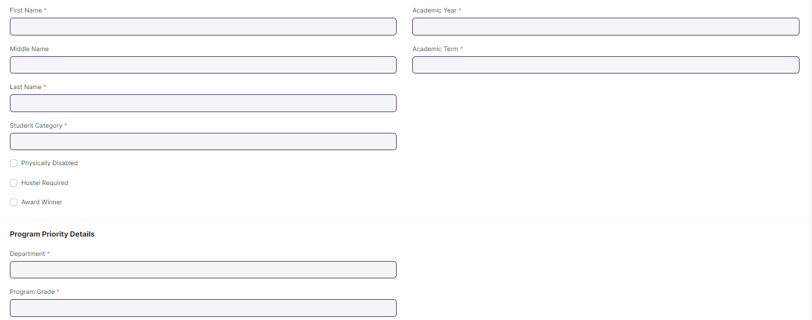

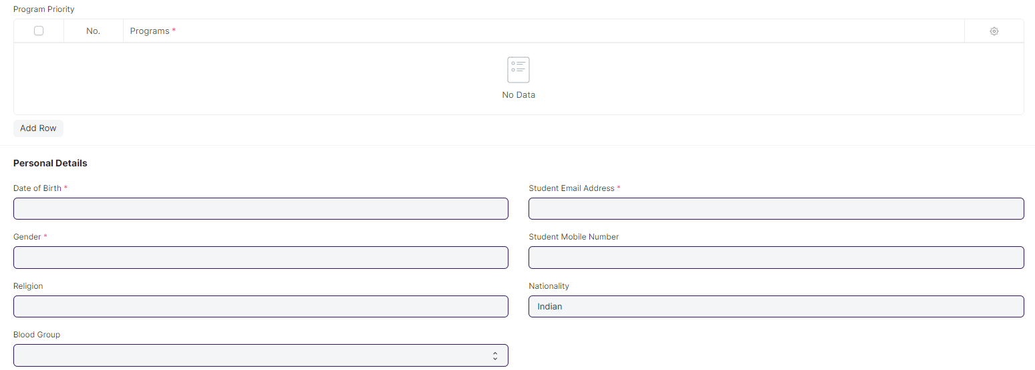

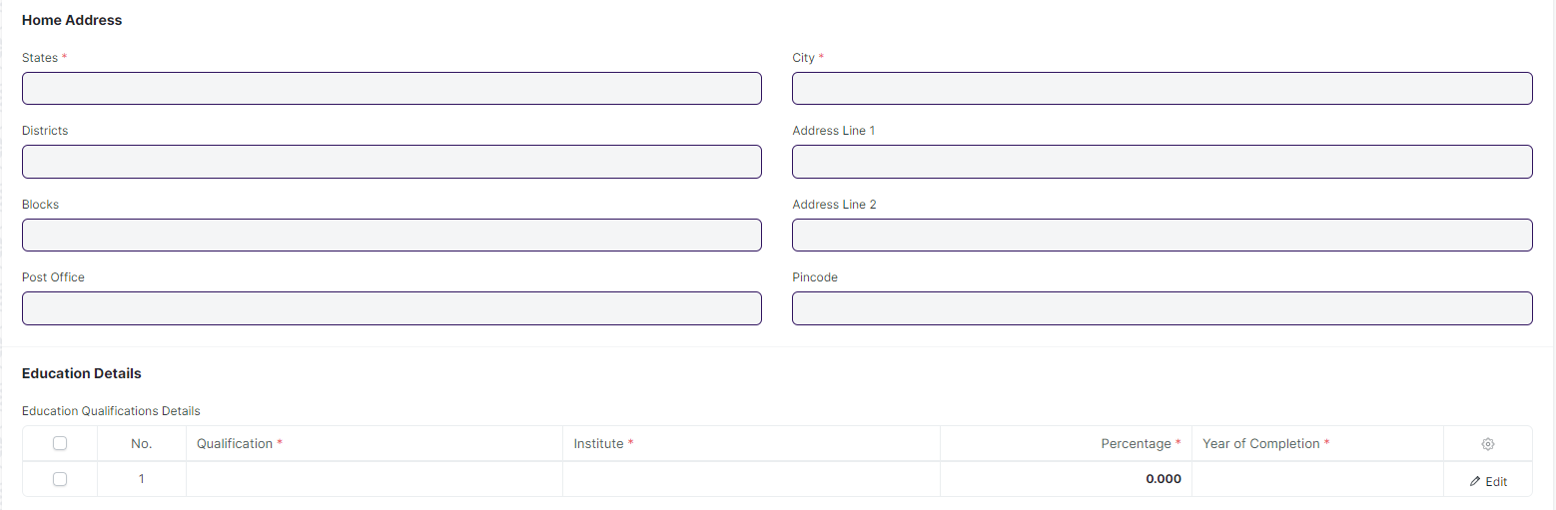

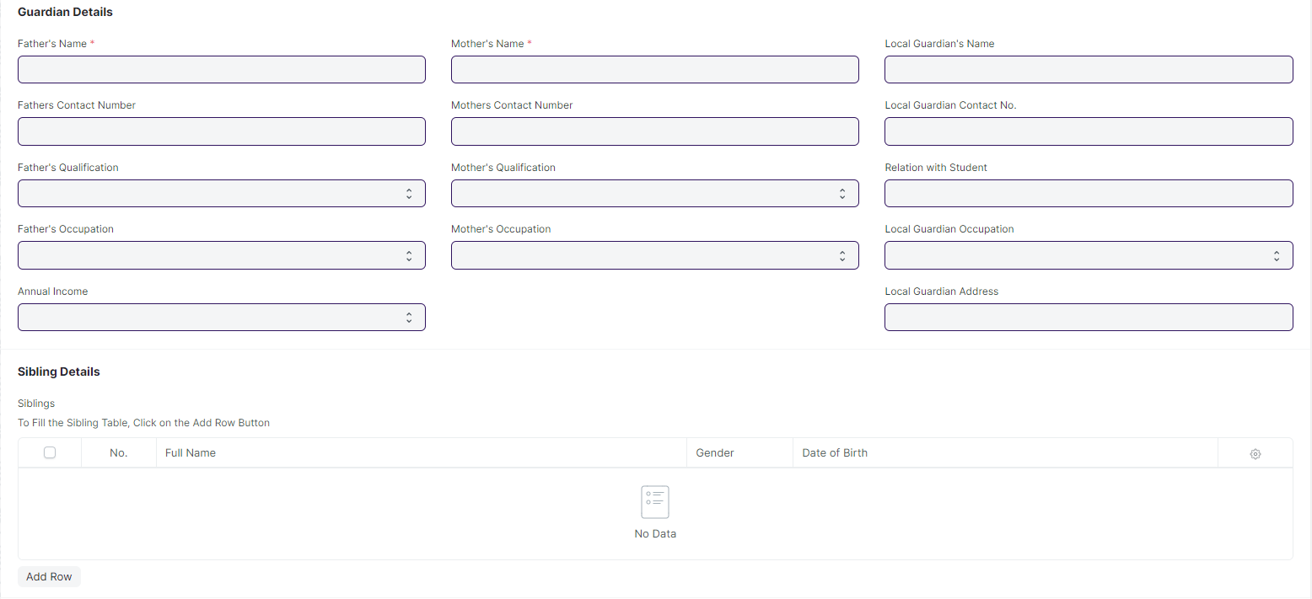

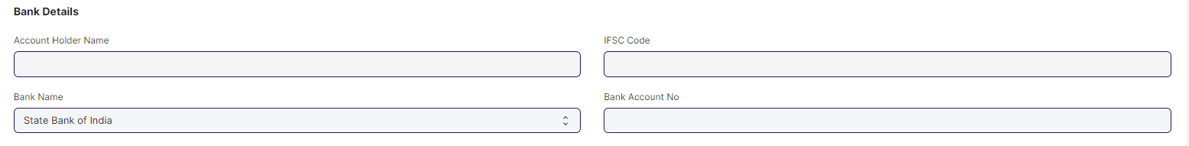

#### **Business Requirements:**

* The **Hostel Required** field will be hidden and the check-in will be set to the default value.
* The City field will be renamed as City / Town / Village
* An option needs to be added for selecting an entrance **Exam Centre** and **Exam City** preference.
* In **Exam Center** preference following field will be added:

1. College Name
2. College Address (each district will have at least one center)

* There will be a **Course Choice** option.
* The **age** must be validated against the age limit parameter.
* **Following fields will be mandatory:**

1. Email ID
2. Gender
3. Blood Group
4. DOB
5. State
6. District
7. Block
8. City / Town / Village
9. Address Line 1
10. Pincode

* The **Gender** field in the student applicant screen should only have the options of **Male, Female, and Other.**
* The **Email ID** is verified when signing up.
* An option should be available in the system which allows the applicant to apply for **both SOS and SOE**.
* Applicants for **SOE** must have either an IIT or a Diploma in Engineering.
* Applicants for **SOS** must have a +2 certificate or a diploma in any discipline.
* **Rank** will be determined by category, such as **SC Ranking, ST Ranking, General Ranking, OBC Ranking, Total Ranking, SC Woman Ranking, ST Woman Ranking**, and so on.
* **Re-counselling** is done for students who are not able to obtain their desired course.

**Remarks:** The removal of the Bank Details section should be discussed at a later date.

**Student Applicant Admit Card**

* The applicants will need to download admit cards from their portal, which will contain the **Date and time, venue, course, department, address and General instructions** applicable for both **SOE** and **SOS**.

### **Program Enrollment**

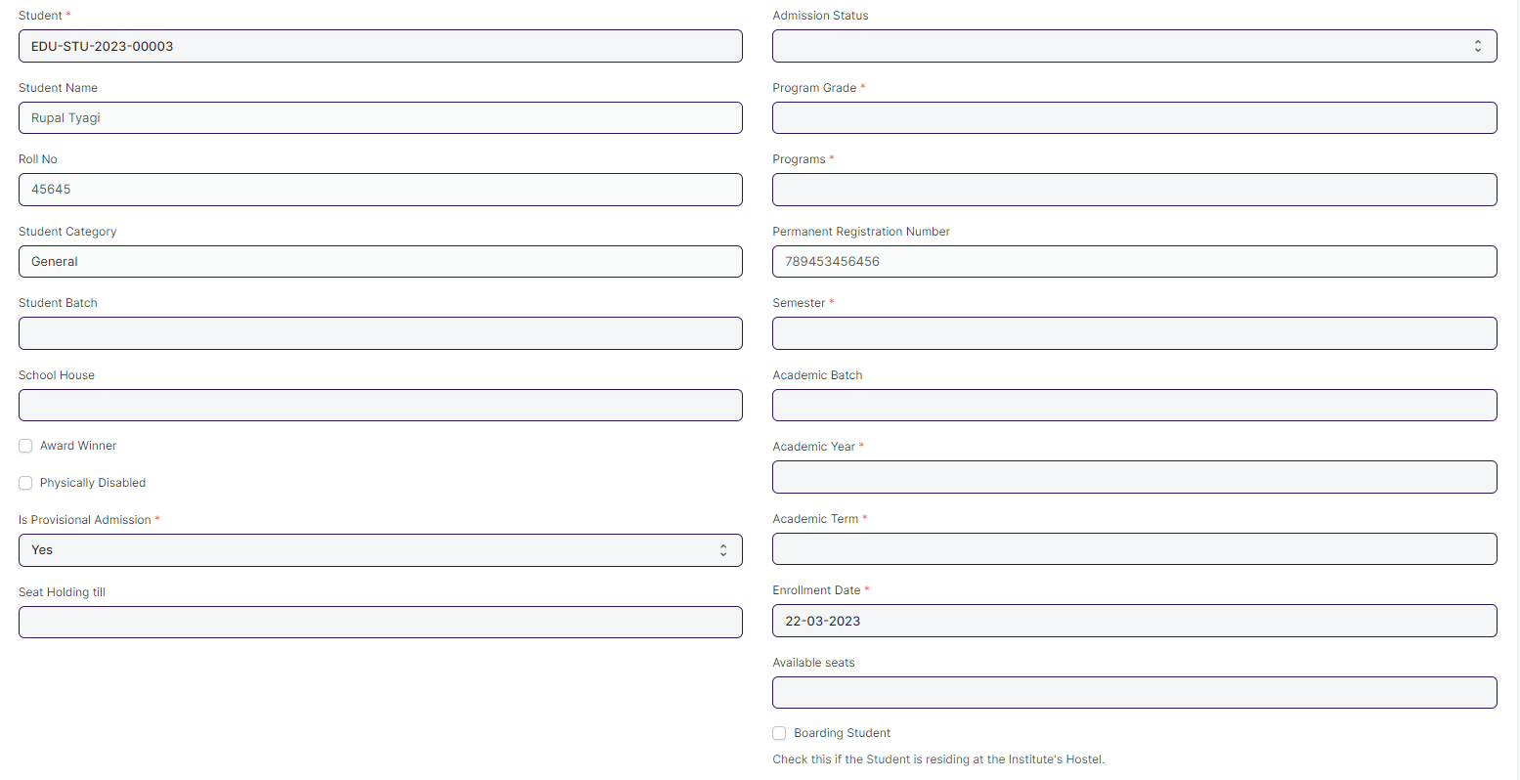

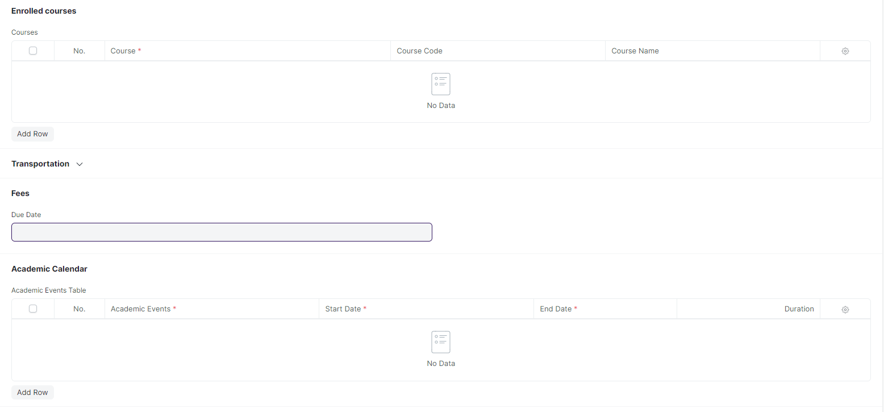

#### **Business Requirements:**

* No changes needed as discussed.

### **Course Enrollment**

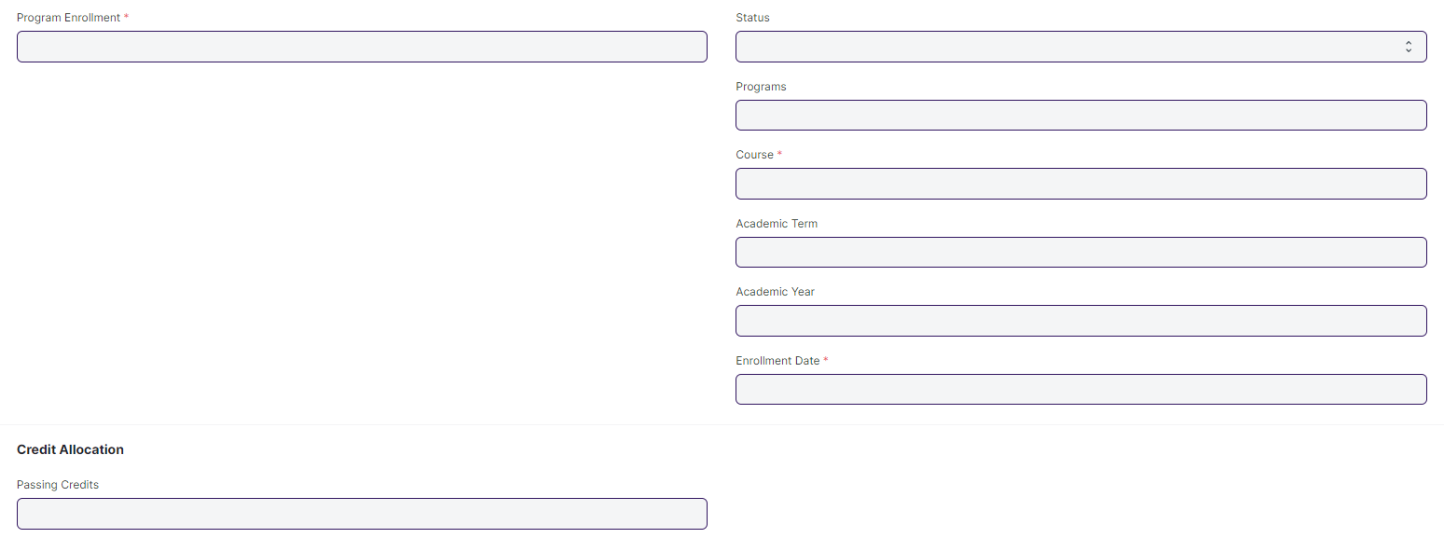

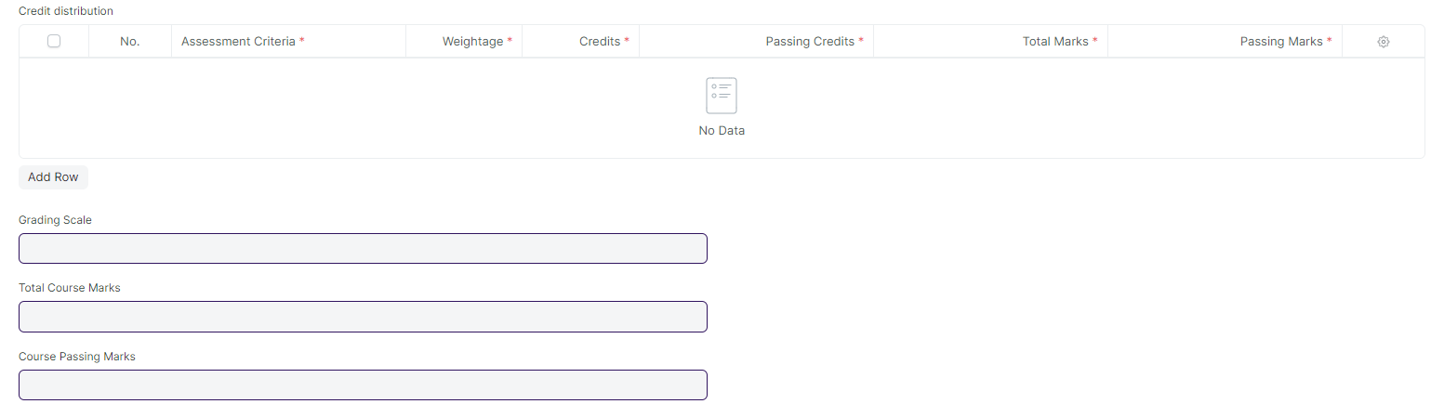

#### **Business Requirements:**

* No changes needed as discussed.

## **Fees**

### **Fee Structure**

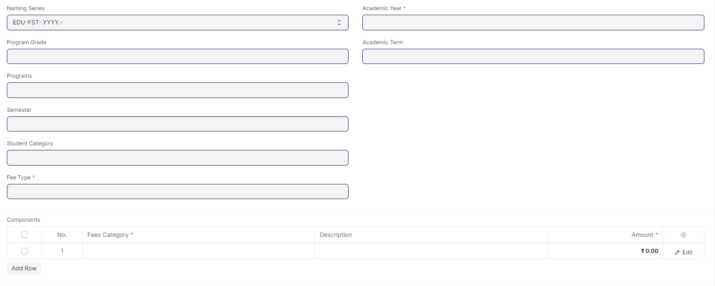

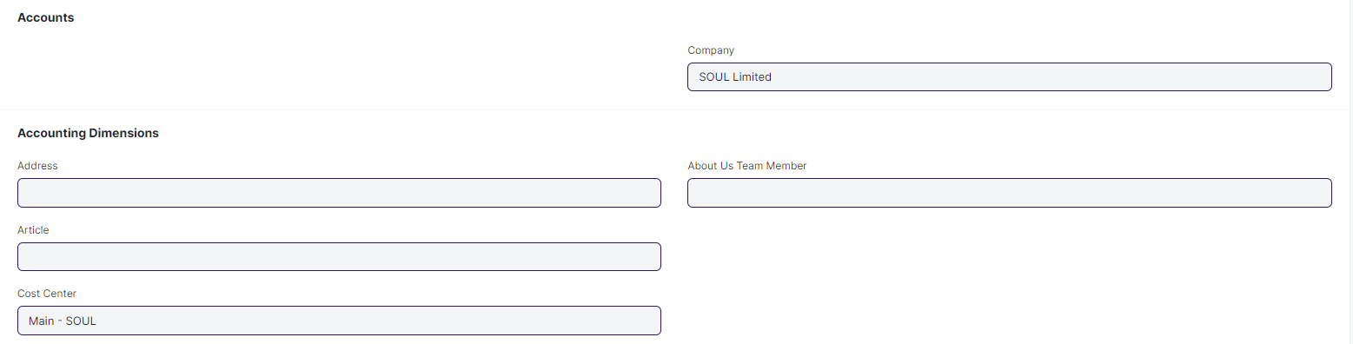

#### **Business Requirements:**

* No changes needed as discussed.

### **Fee Schedule**

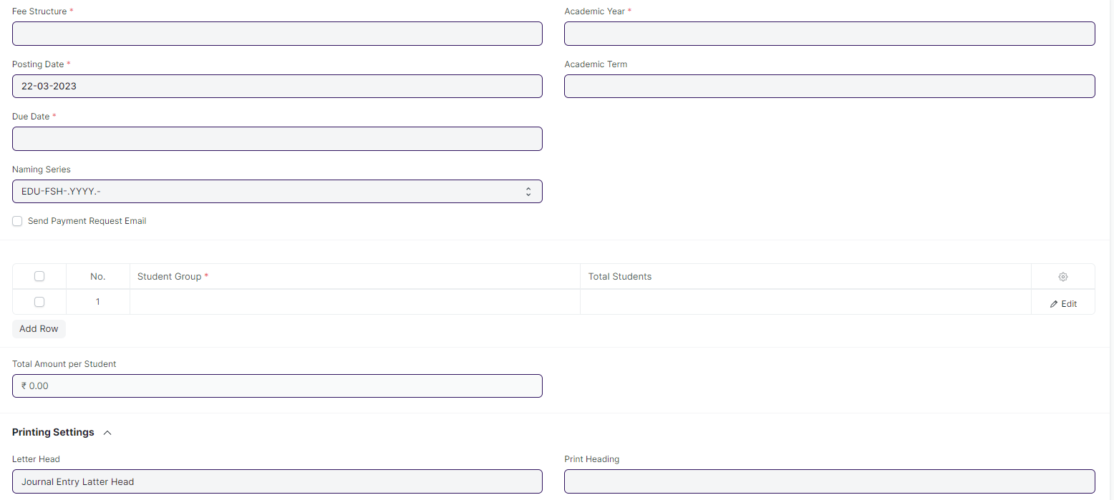

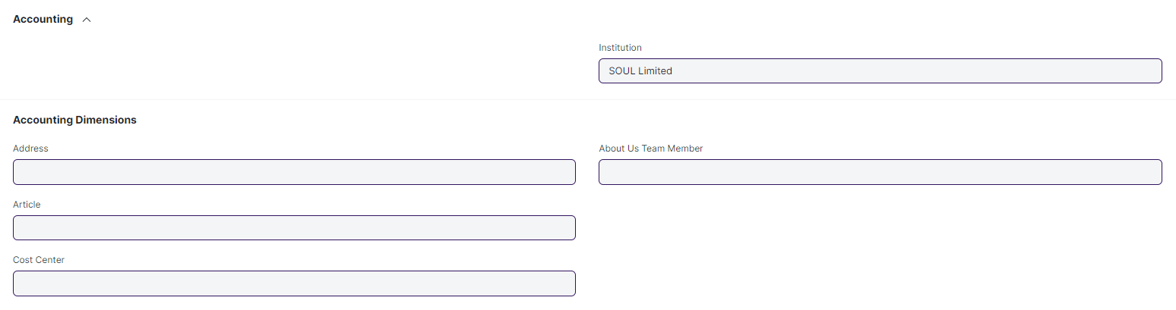

#### **Business Requirements:**

* No changes needed as discussed.

### **Fee Category**

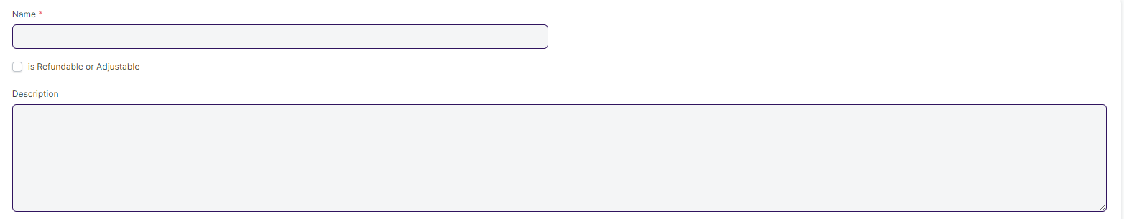

#### **Business Requirements:**

* No changes needed as discussed.

### **Fees**

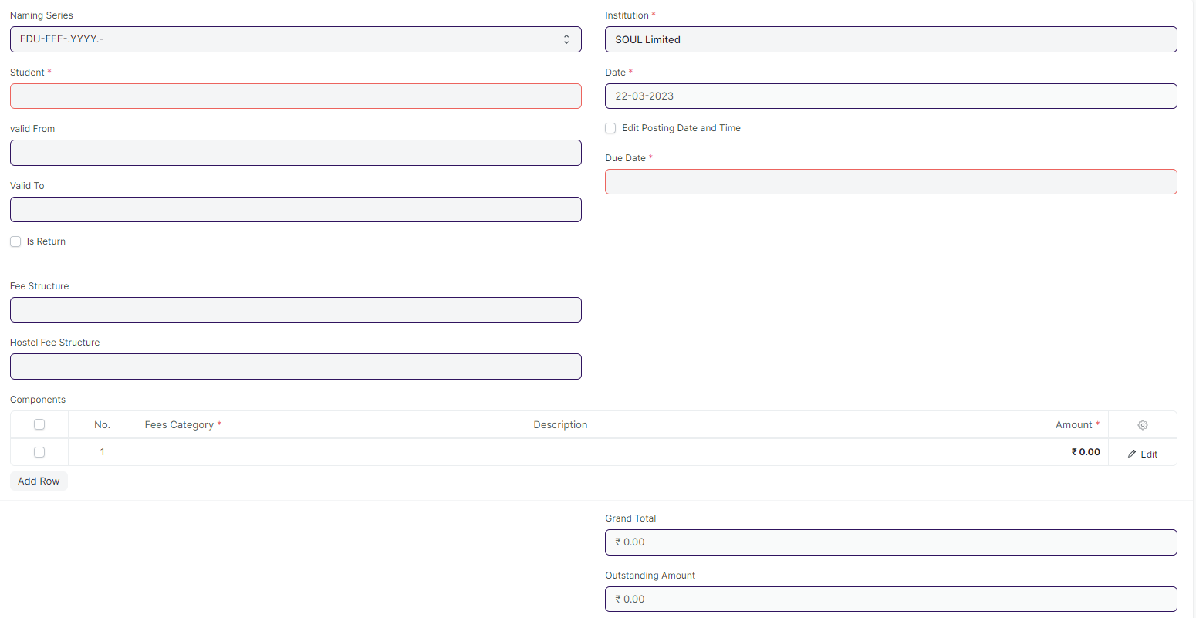

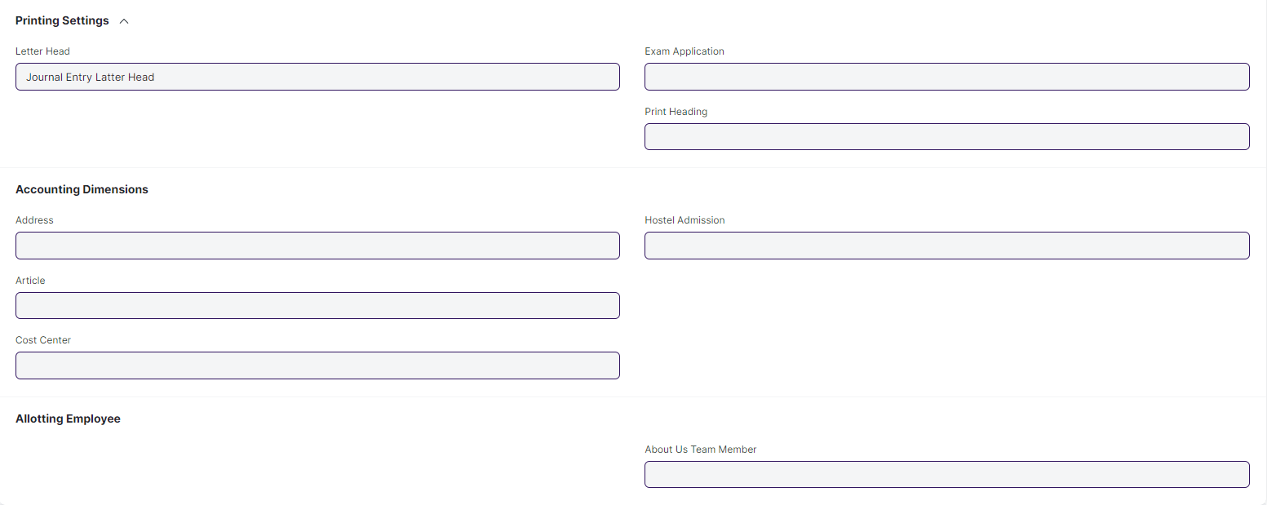

#### **Business Requirements:**

* No changes needed as discussed.

## **Tools**

### **Student Reregistration Tool**

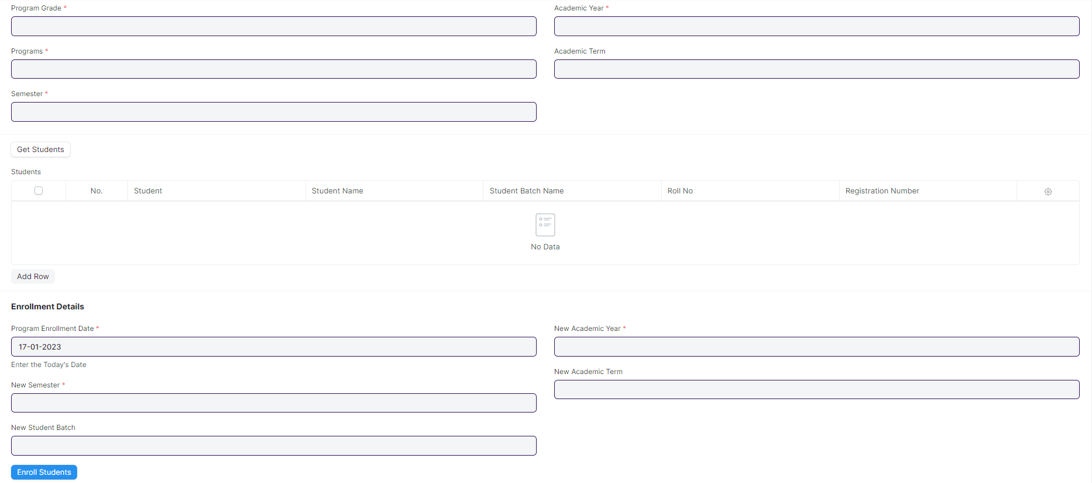

#### **Business Requirements:**

* No changes needed as discussed.

## **Settings**

### **Education Setting**

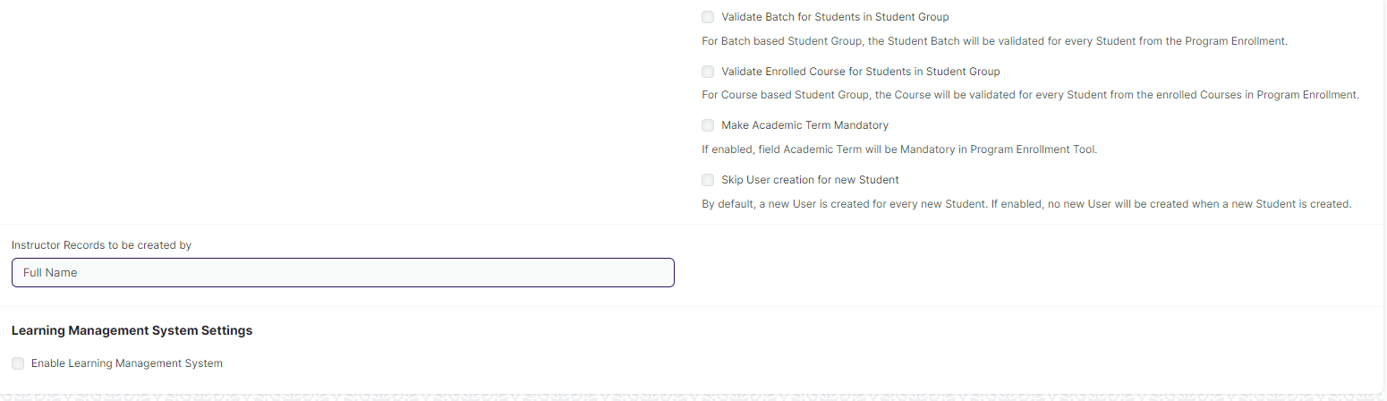

#### **Business Requirements:**

* No changes needed as discussed.

### **Education Configuration**

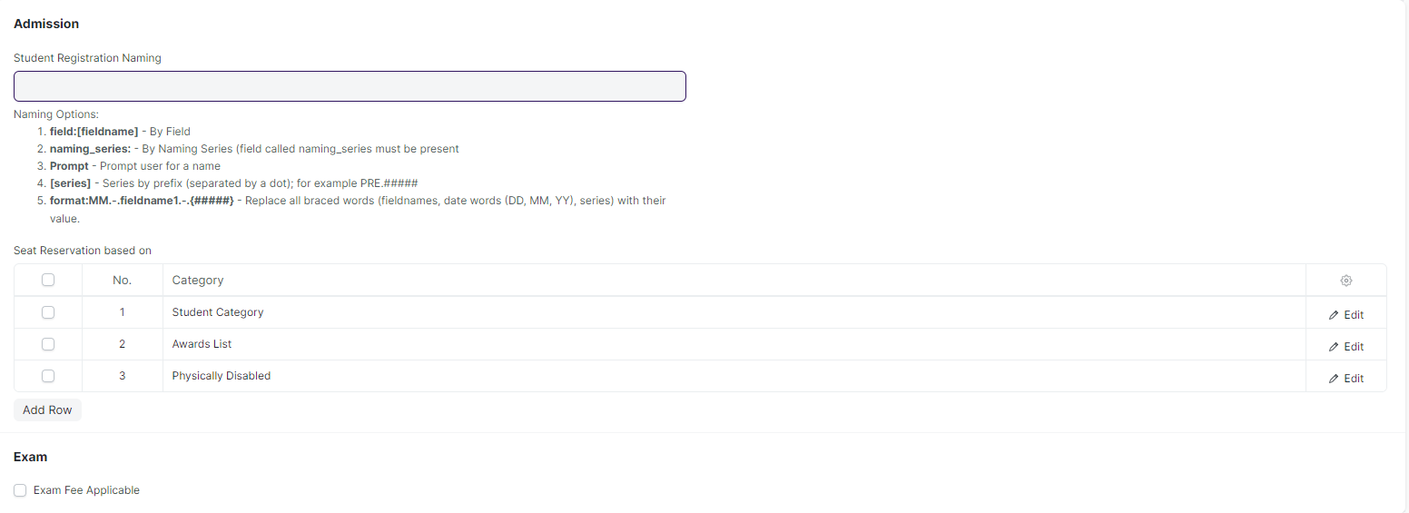

#### **Business Requirements:**

* No changes needed as discussed.

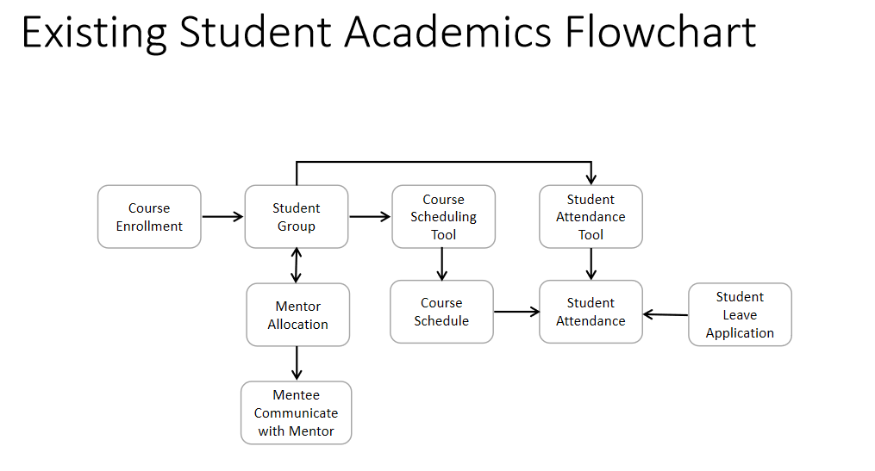

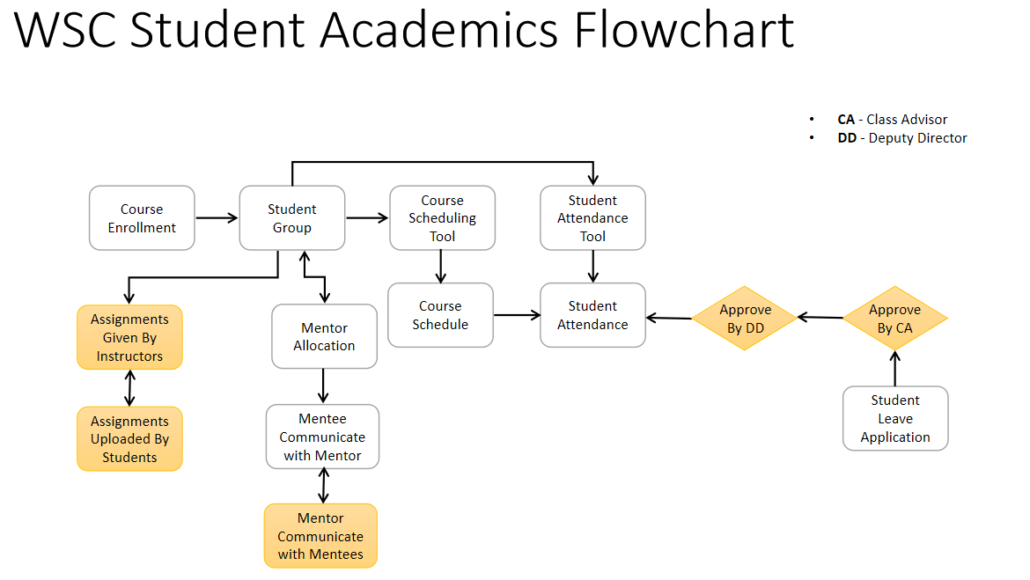

# **Academics**

## **Groups & Schedules**

### **Student Group**

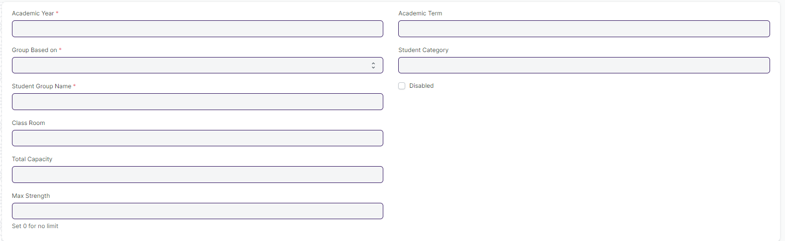

#### **Business Requirements:**

* No changes needed as discussed.

### **Course Schedule**

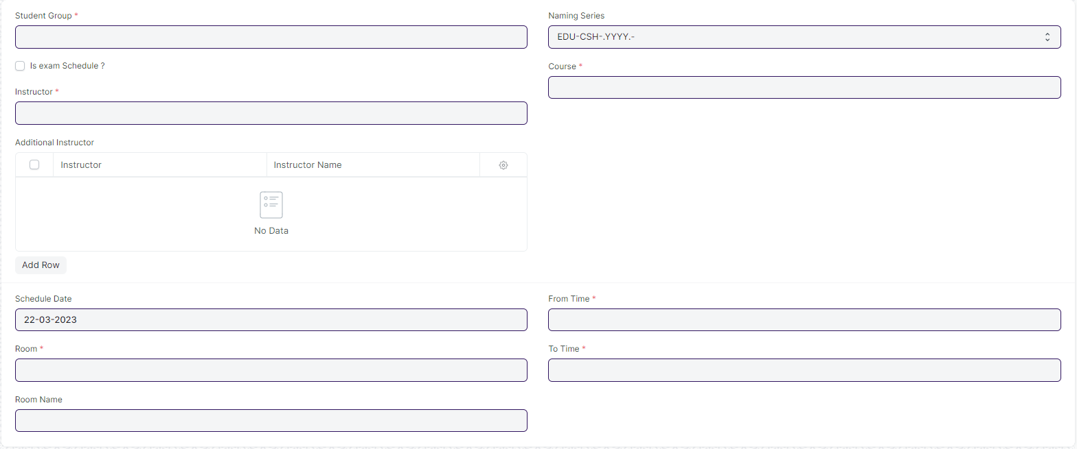

#### **Business Requirements:**

* No changes needed as discussed.

## **Attendance & Leave Application**

### **Student Attendance**

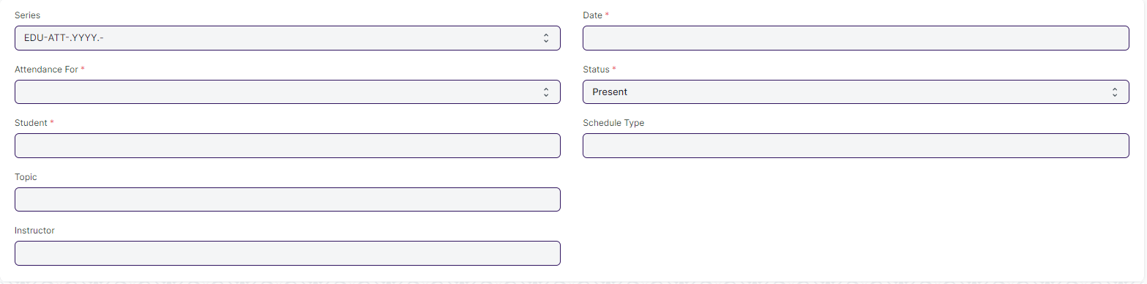

#### **Business Requirements:**

* In **Student Attendance** Screen Students' attendance must be provided before a specific deadline.

### **Student Attendance Tool**



#### **Business Requirements:**

* In **Student Attendance** Screen Students' attendance must be provided before a specific deadline.

### **Student Leave Application**

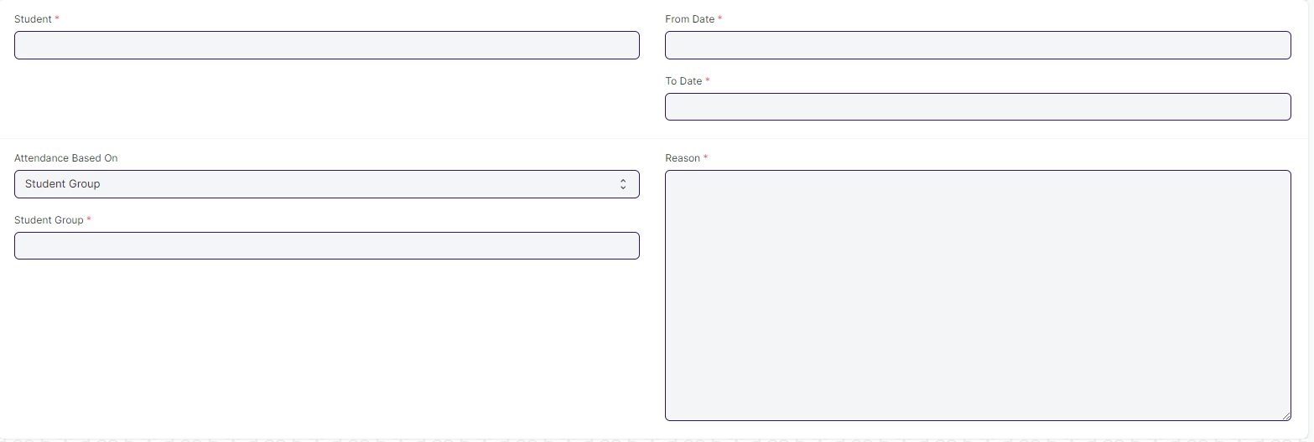

#### **Business Requirements:**

* A workflow needs to be added to the **Student Leave Application** screen in order to add the hierarchy of approving managers.
* Workflow Actions:

1. Approve
2. Reject

* Single Screen for Student Leave Application form
* Need to merge the two leave application form which are present in hostel and academic in to a single screen.

## **Mentor Mentee**

### **Mentor Allocation**

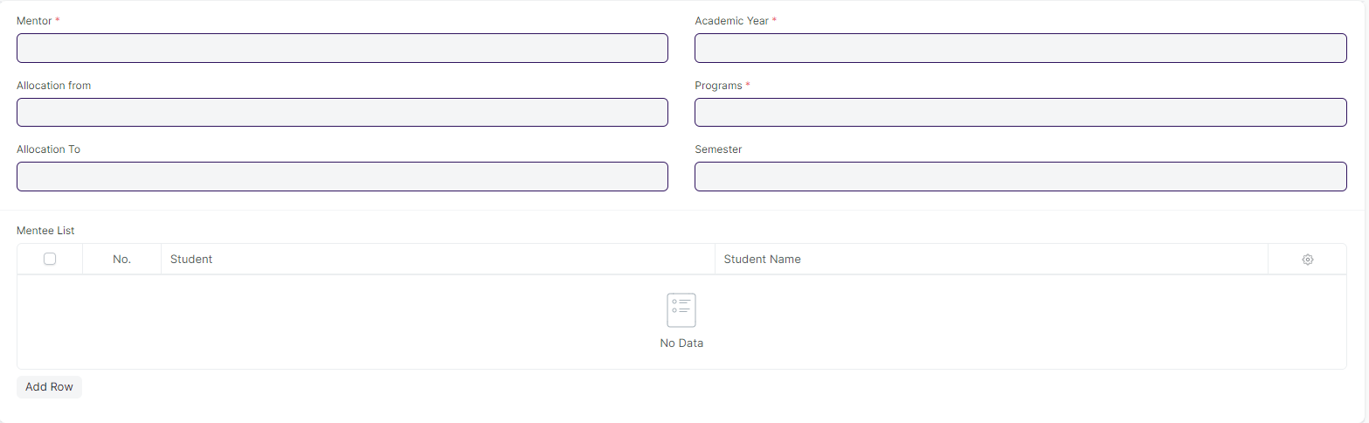

#### **Business Requirements:**

* No changes needed as discussed.

### **Mentor Mentee Communication**

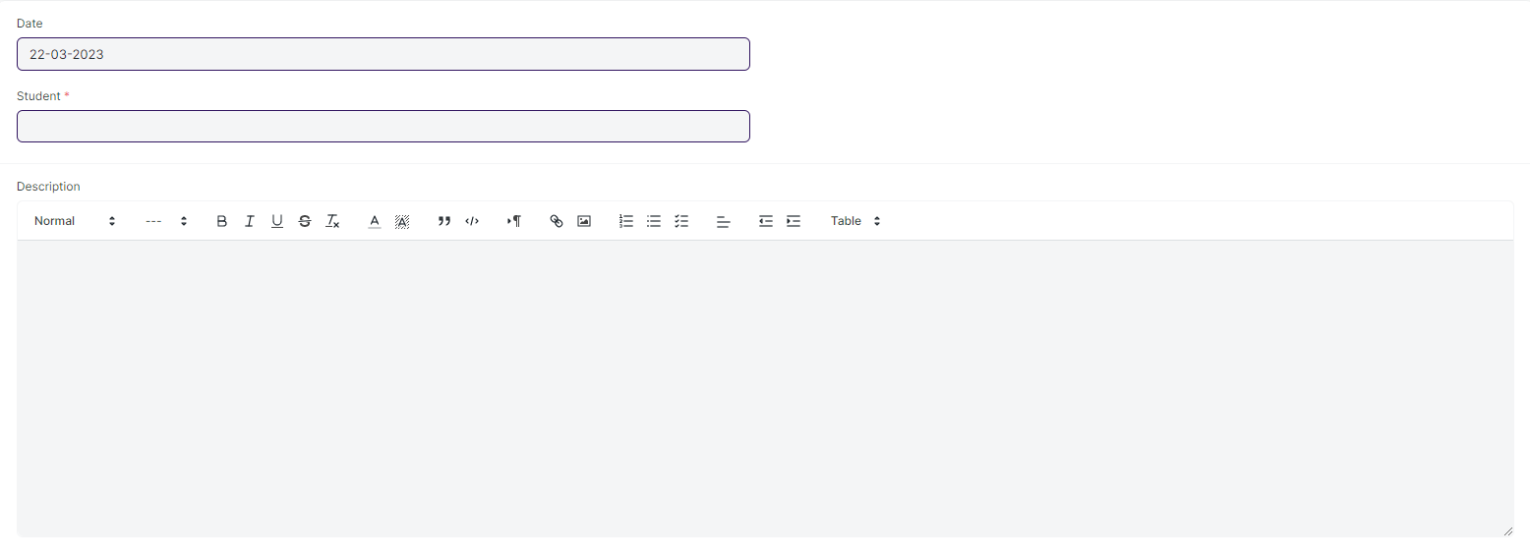

#### **Business Requirements:**

* In the **Mentor Mentee Communication** Screen, where mentors can message their students, a reply feature should be added so that mentors can respond to their respective mentees.

## **Placement & Drives**

### **Placement Company**

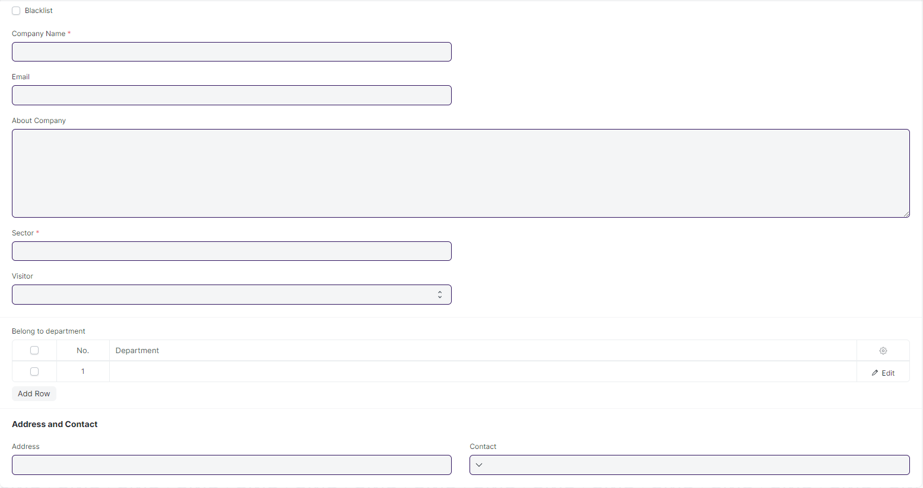

#### **Business Requirements:**

* No changes needed as discussed.

### **Placement Drive**

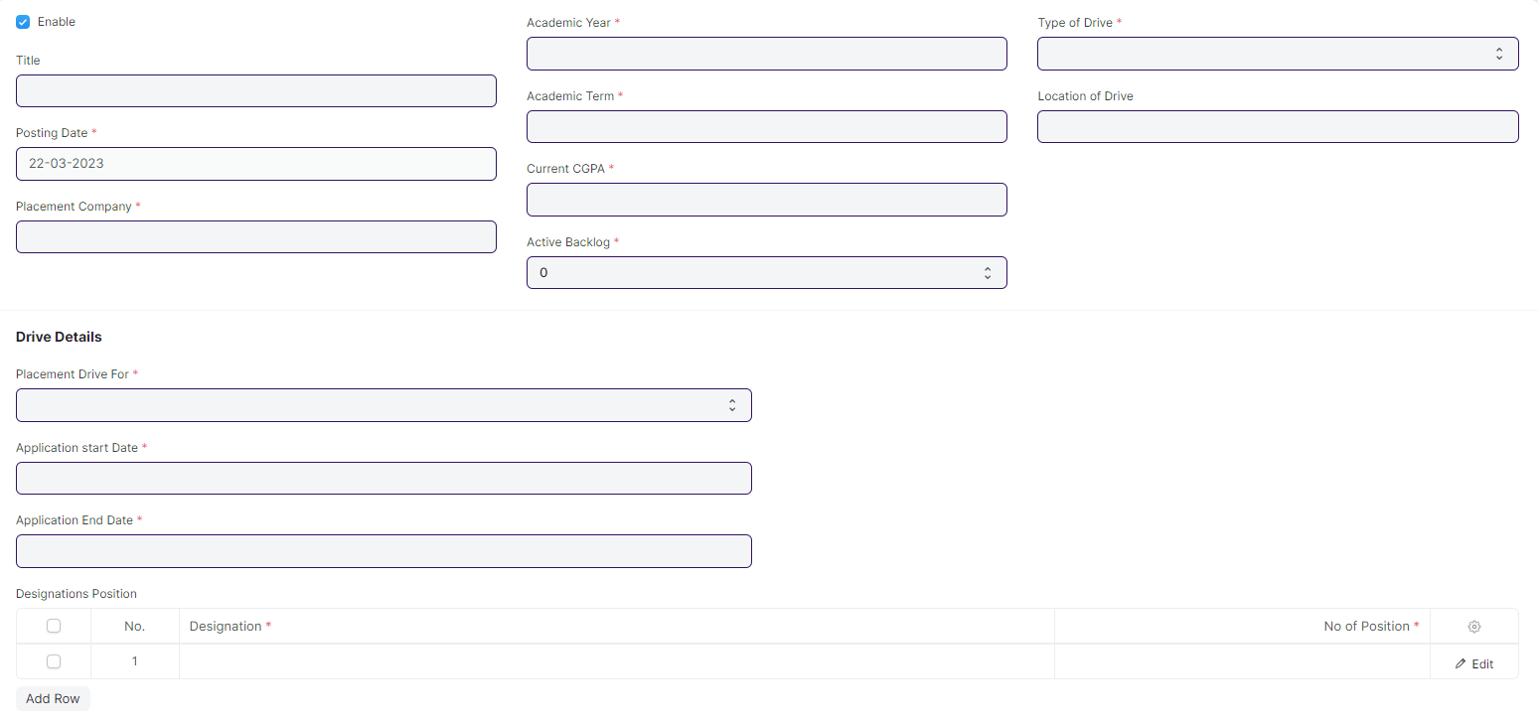

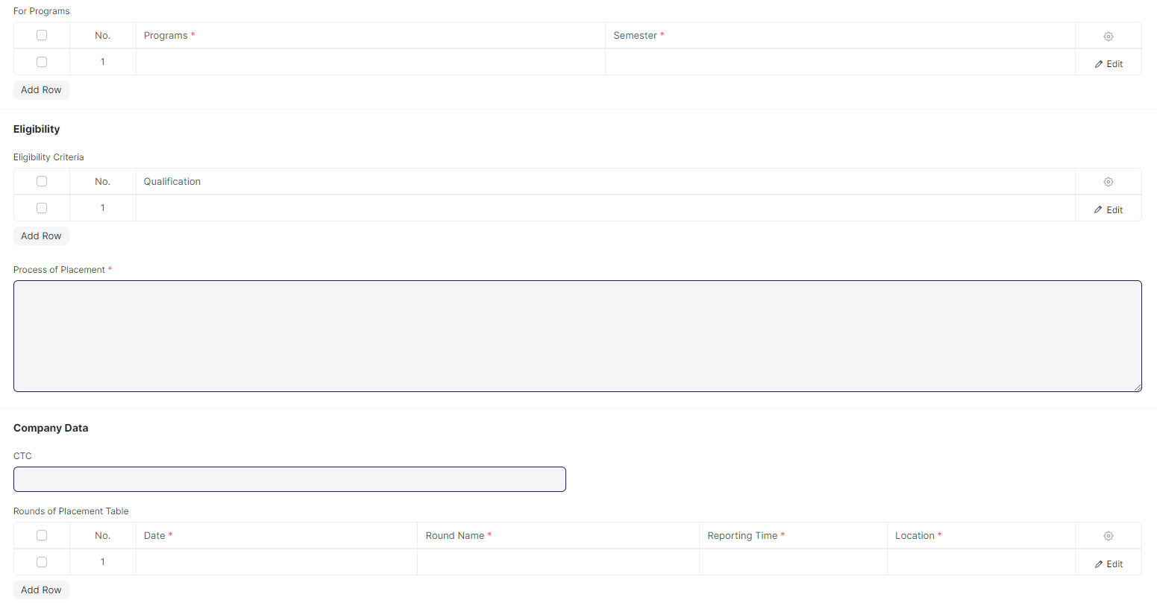



#### **Business Requirements:**

* No changes needed as discussed.

### **Placement Drive Application**

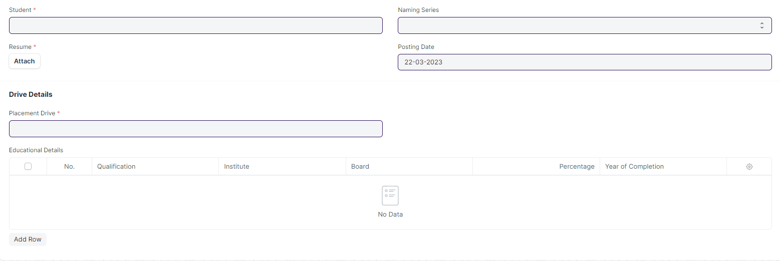

#### **Business Requirements:**

* No changes needed as discussed.

## **Tools**

### **Course Scheduling Tool**

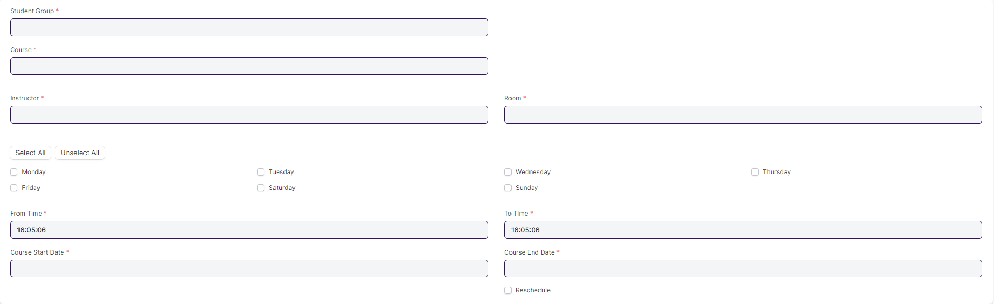

#### **Business Requirements:**

* No changes needed as discussed.

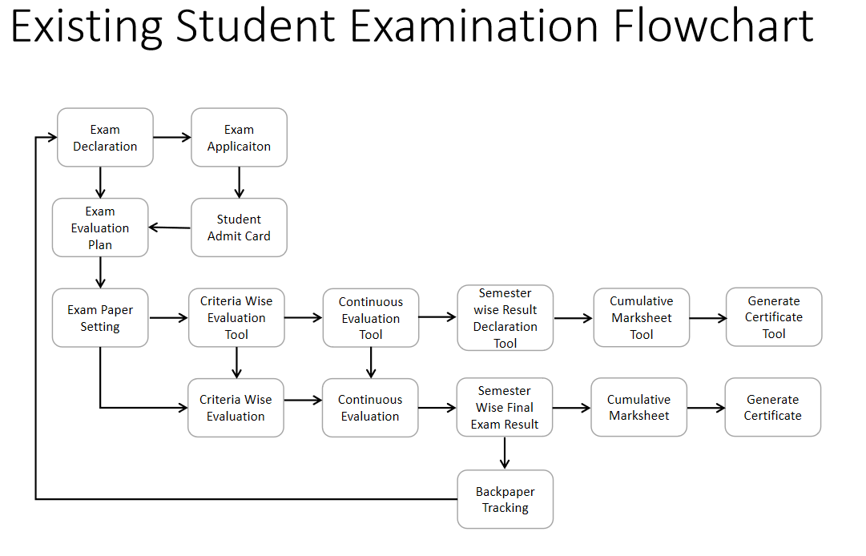

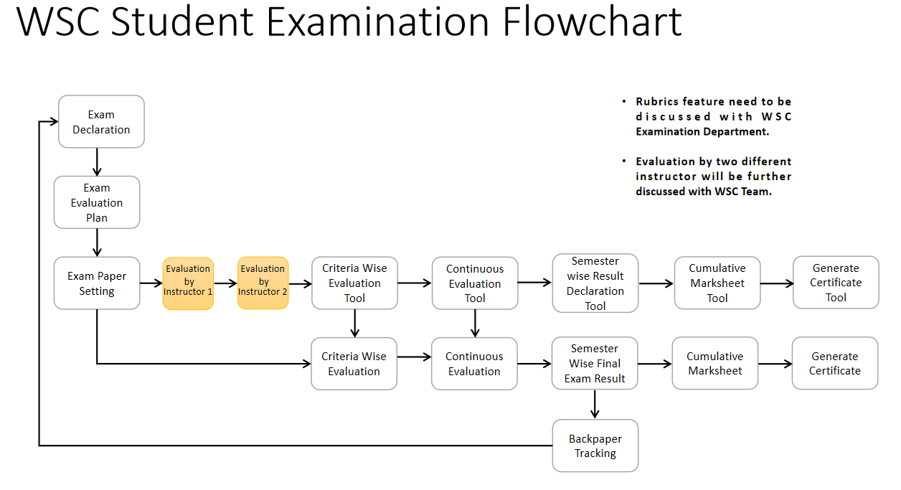

# **Examination**

## **Examination Master**

### **Exam Type**

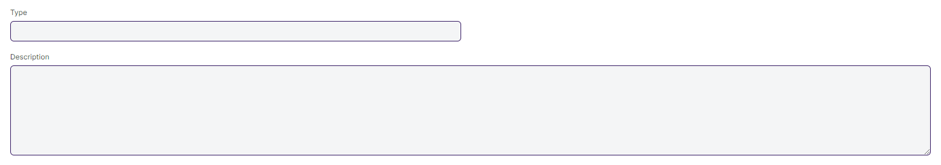

#### **Business Requirements:**

* No changes needed as discussed.

### **Assessment Criteria**

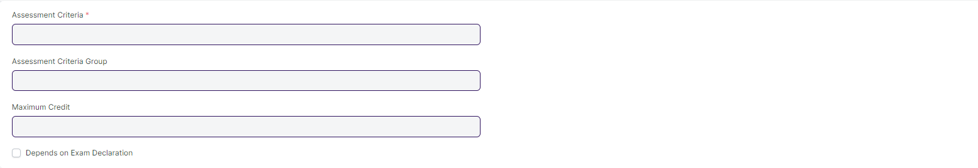

#### **Business Requirements:**

* No changes needed as discussed.

### **Grading Scale**

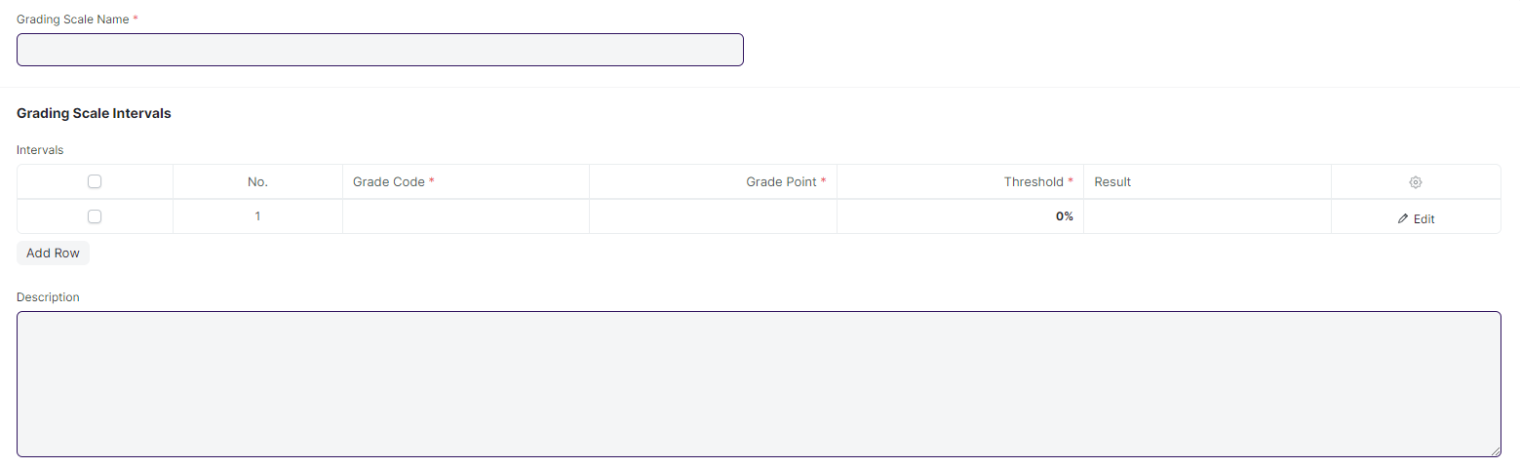

#### **Business Requirements:**

* No changes needed as discussed.

### **Student Exam Block Criteria**



#### **Business Requirements:**

* No changes needed as discussed.

## **Examination**

### **Exam Declaration**

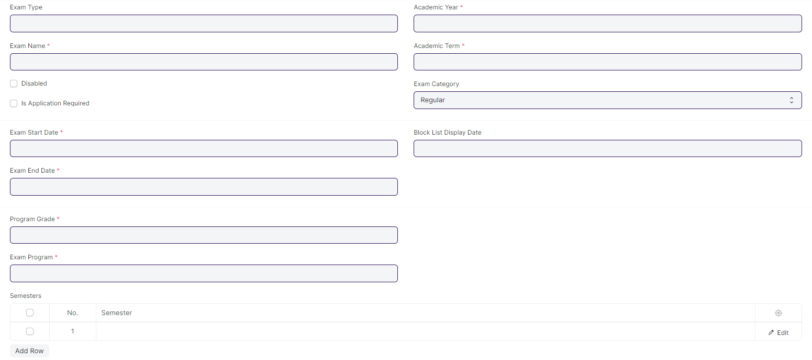

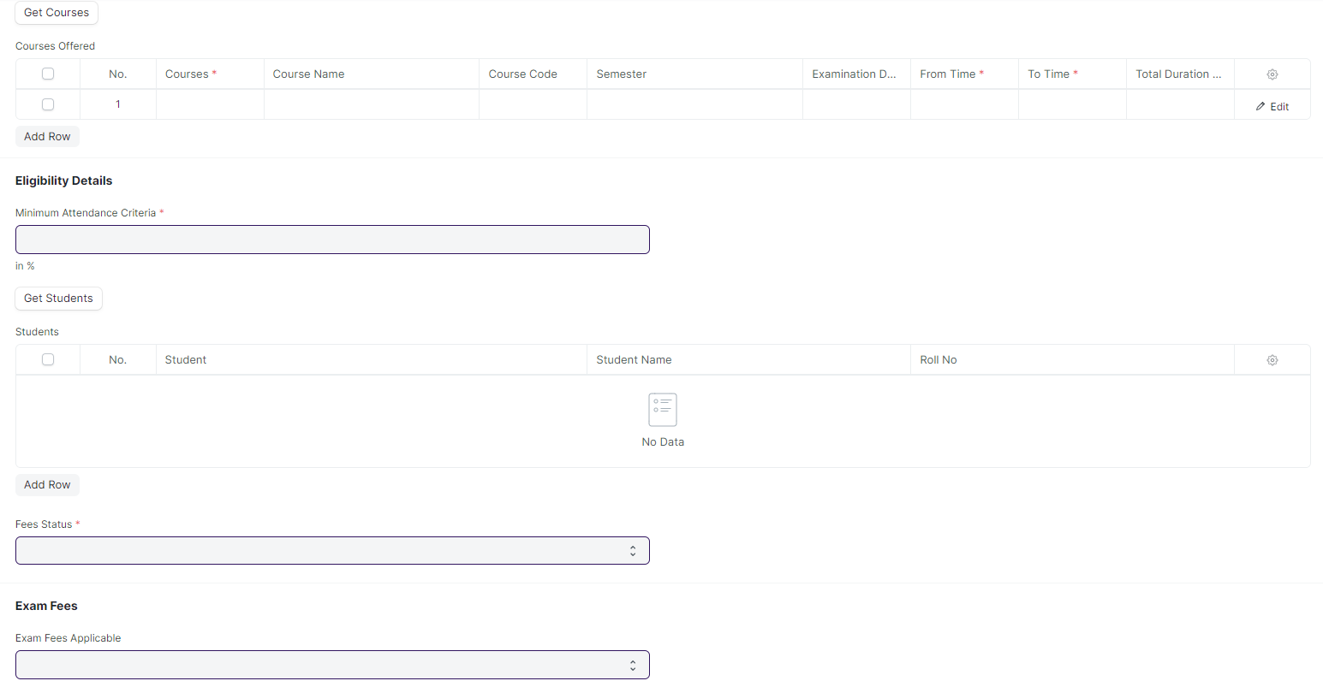

#### **Business Requirements:**

* One field must be added to the course offered table of the **Exam Declaration** screen to identify the conducting venue for their respective courses.
* A provision to assign an invigilator, a marker, and a checker should be included in the exam declaration screen for a specific course.
* If a student fails either semester 1, they will have to take a retest before the start of semester 2.

### **Exam Application**

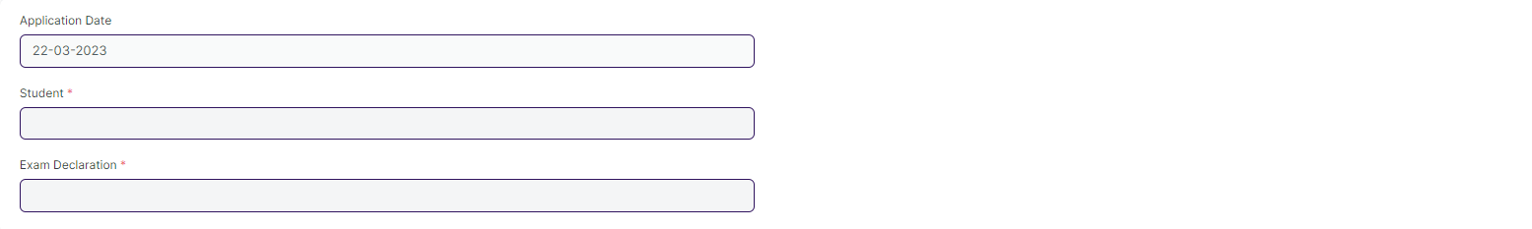

#### **Business Requirements:**

* If a student fails either Semester I, they will have to take a retest before the start of Semester II.

### **Exam Paper Setting**

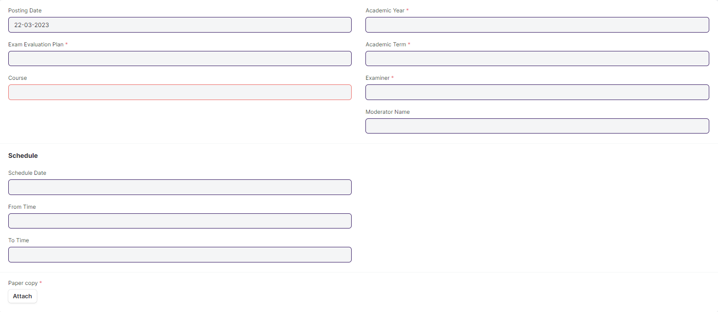

#### **Business Requirements:**

* After the paper setter moderator list is published, the paper setter will take three weeks to set the paper, and the moderator will take one week to check the paper sets.
* The paper gets reviewed by the reviewer. In case reviewer is unavailable, the paper is reviewed by Dy Director.

### **Student Admit Card**

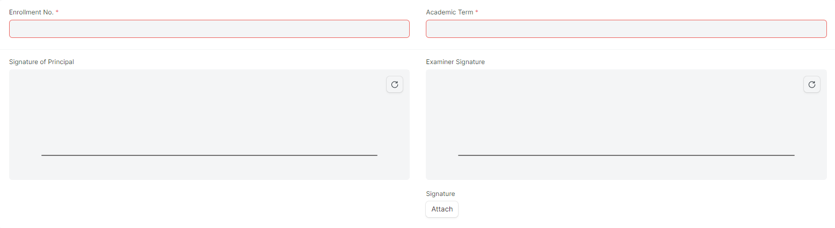

#### **Business Requirements:**

* No changes needed as discussed.

## **Evaluation**

### **Exam Evaluation Plan**

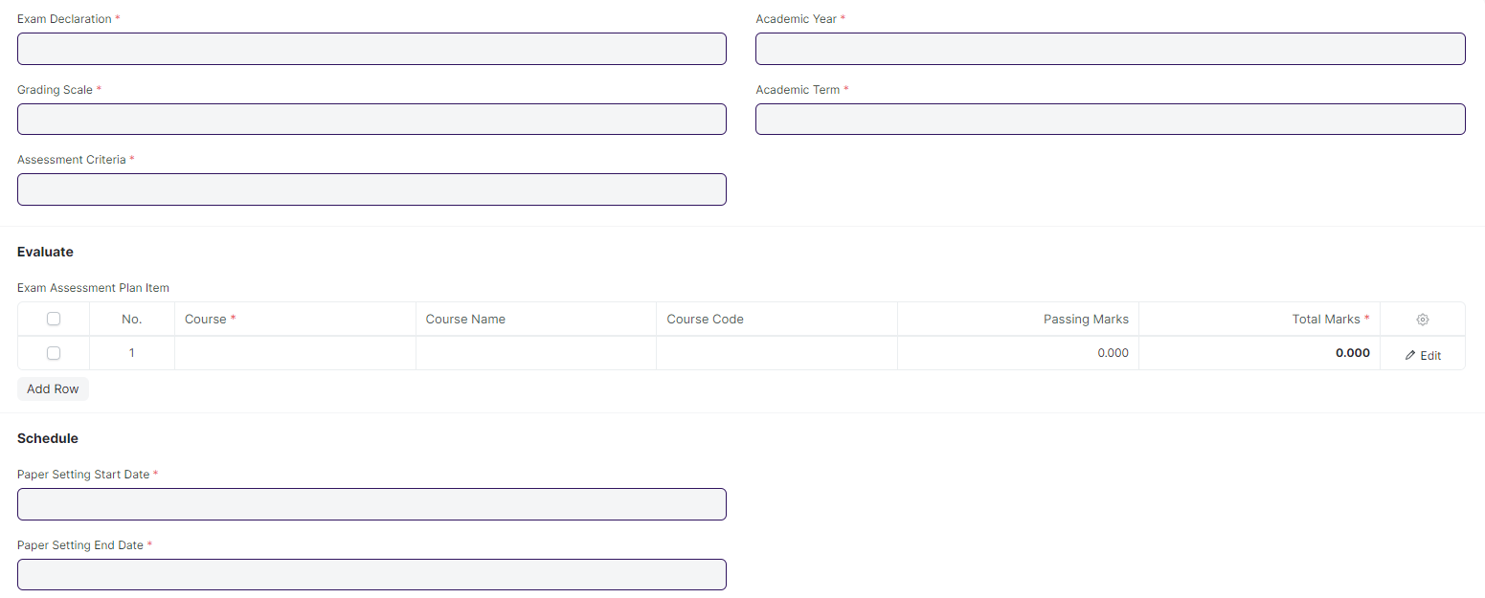

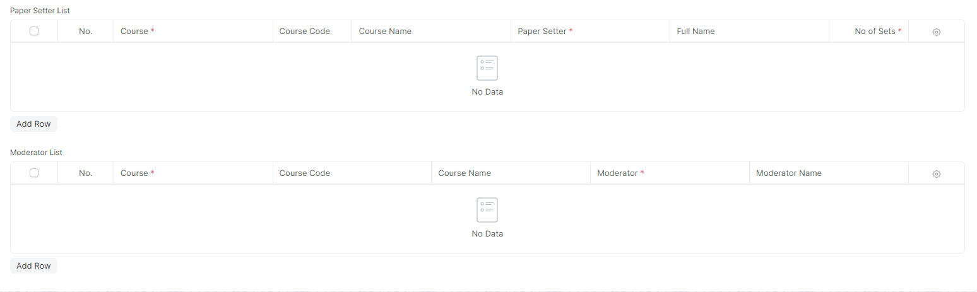

#### **Business Requirements:**

* No changes needed as discussed.

### **Criteria Wise Evaluation**

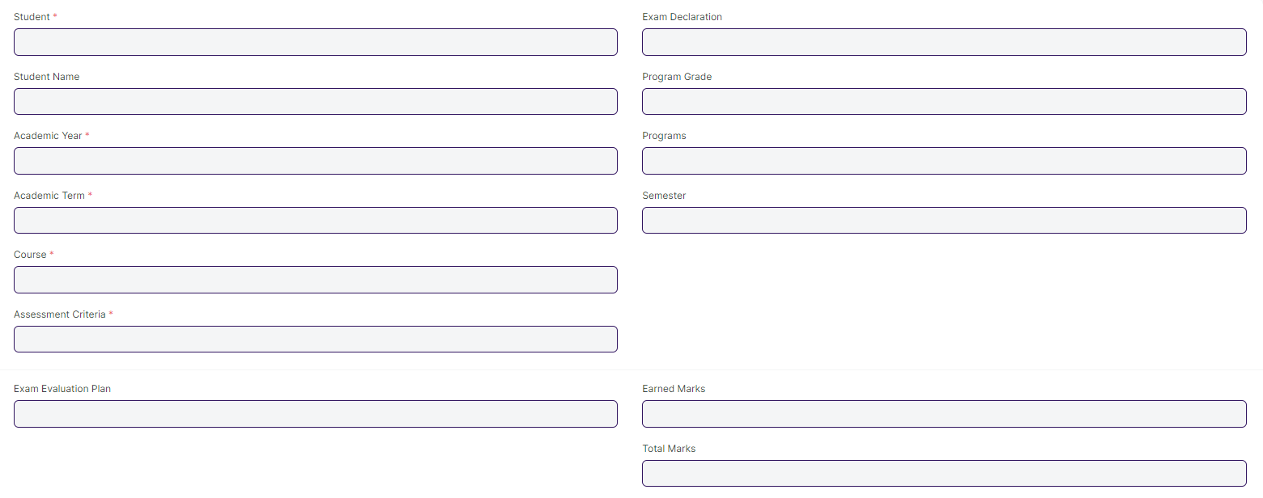

#### **Business Requirements:**

* Two instructors independently evaluate a student's assessment without knowing the other's score and then come together to compare their results and determine the final grade.

**Remarks**: It will discussed whether it will be implement in the system or not.

### **Continuous Evaluation**

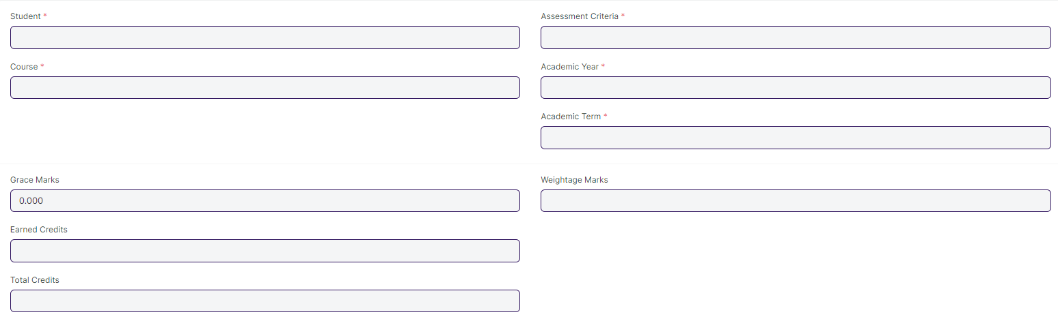

#### **Business Requirements:**

* No changes needed as discussed.

### **Final Exam Result**

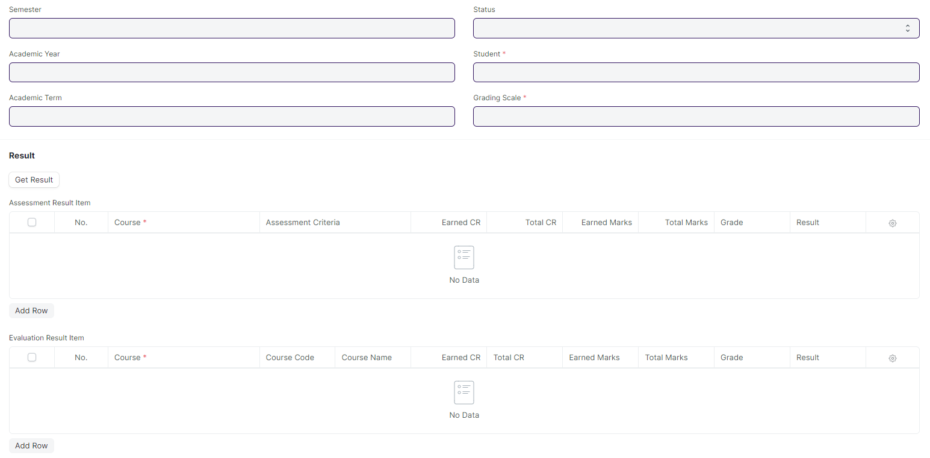

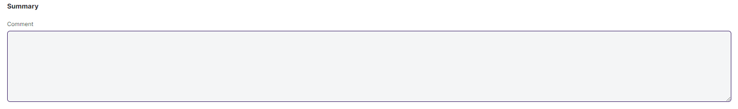

#### **Business Requirements:**

* Remove/Hide the CGPA, SGPA, and Credit features from the Final Exam Result and display the percentage and grade instead.

## **Tools**

### **Criteria Wise Evaluation Tool**

#### **Business Requirements:**

* No changes needed as discussed.

### **Continuous Evaluation Tool**

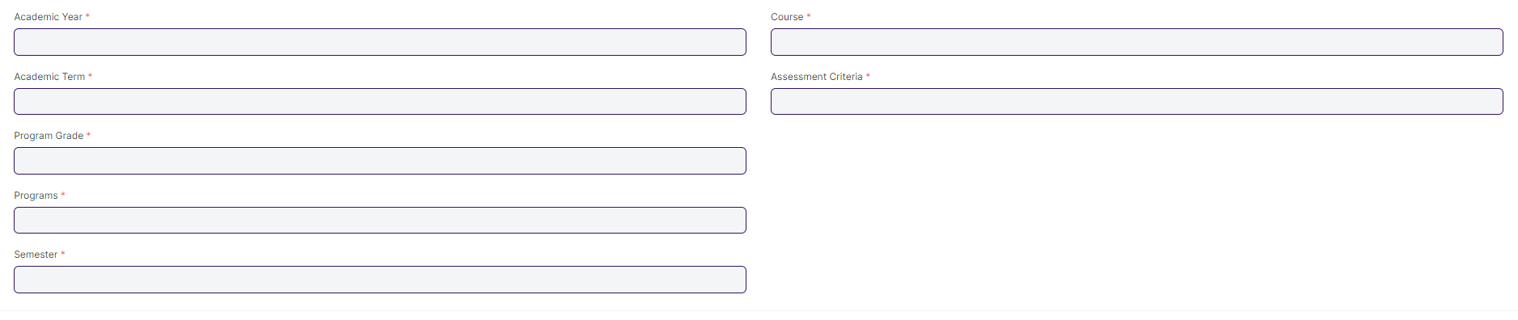

#### **Business Requirements:**

* No changes needed as discussed.

### **Final Result Declaration**

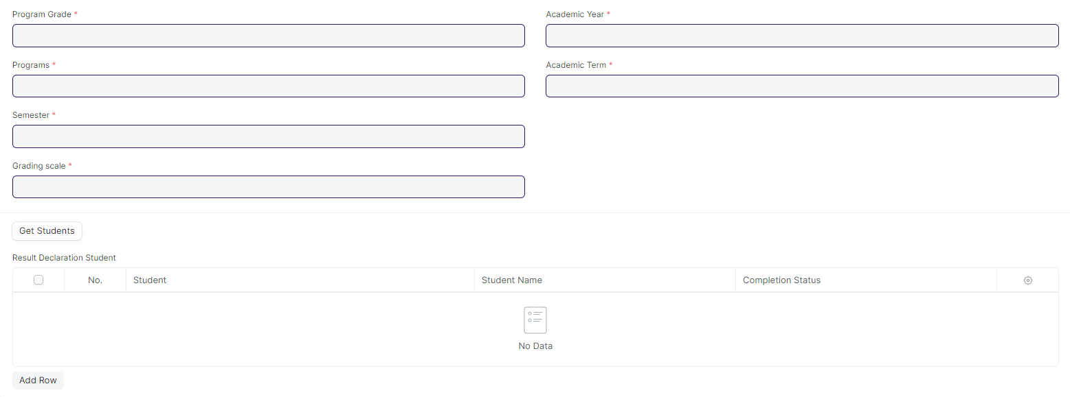

#### **Business Requirements:**

* No changes needed as discussed.

### **Cumulative Mark sheet Tool**

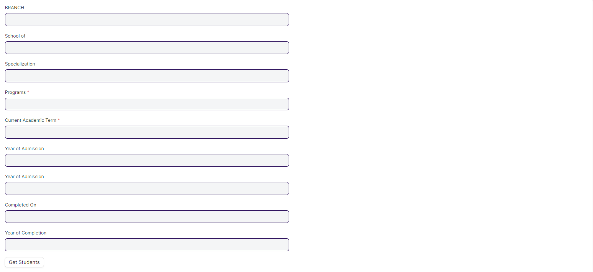

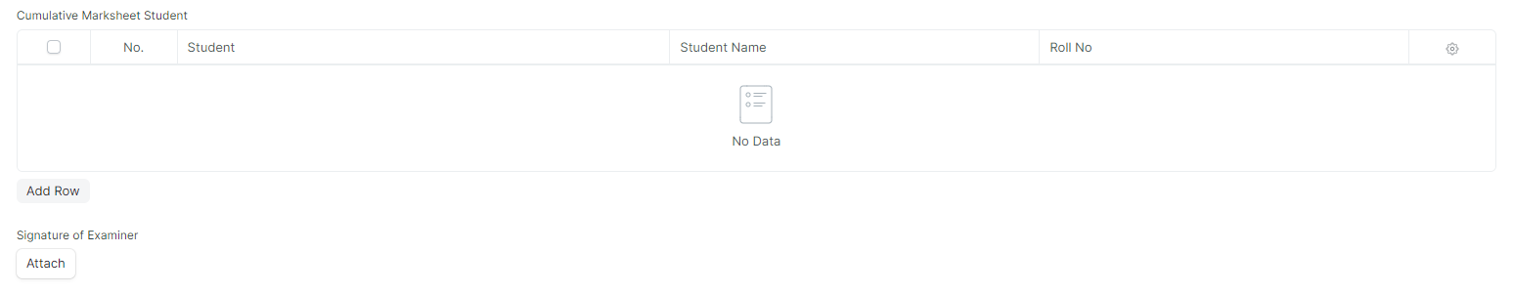

#### **Business Requirements:**

* Remove/Hide the CGPA, SGPA, and Credit features from the Cumulative Mark sheet and display the percentage and grade instead.

### **Provisional Certificate Tool**

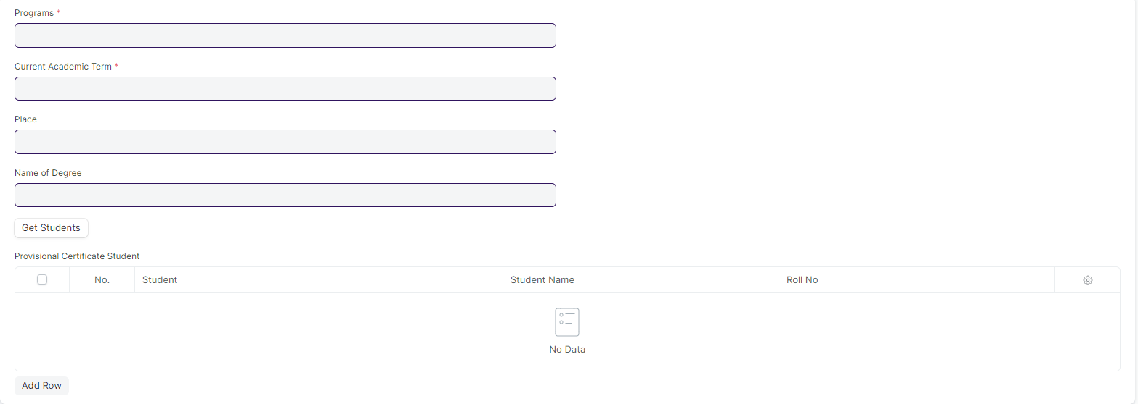

#### **Business Requirements:**

* No changes needed as discussed.

### **Migration Certificate Tool**

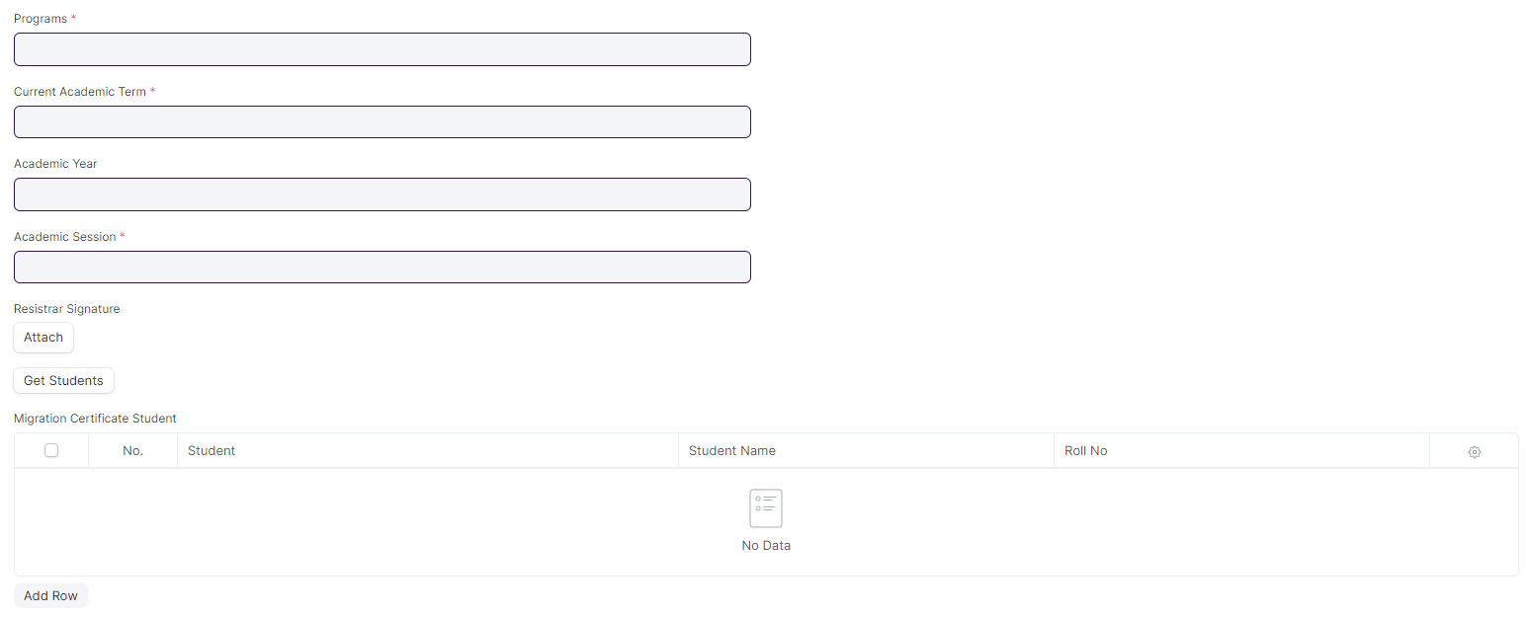

#### **Business Requirements:**

* No changes needed as discussed.

### **Conduct Certificate Tool**

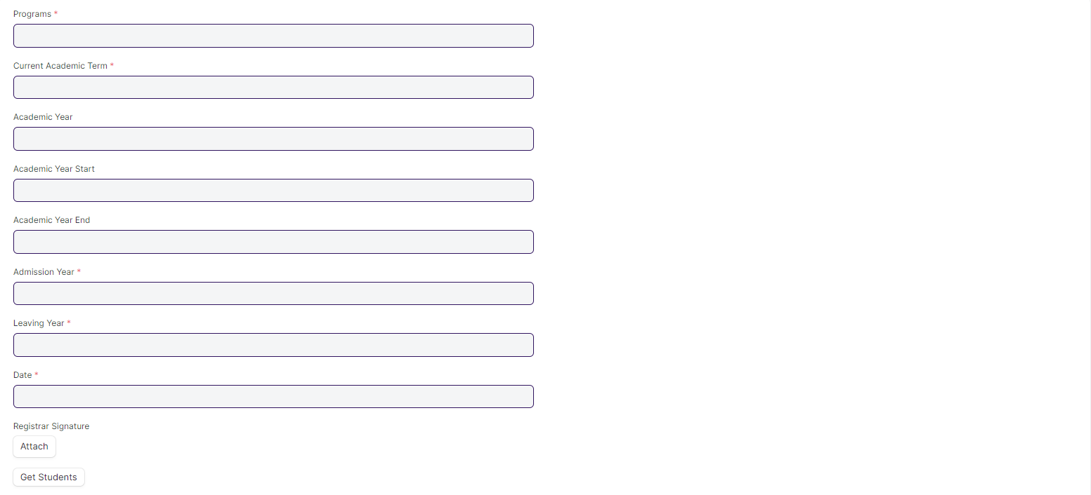

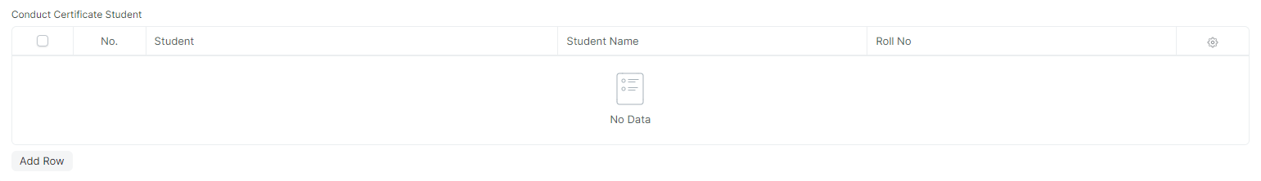

#### **Business Requirements:**

* No changes needed as discussed.

## **Transcripts**

### **Leaving Certificate**

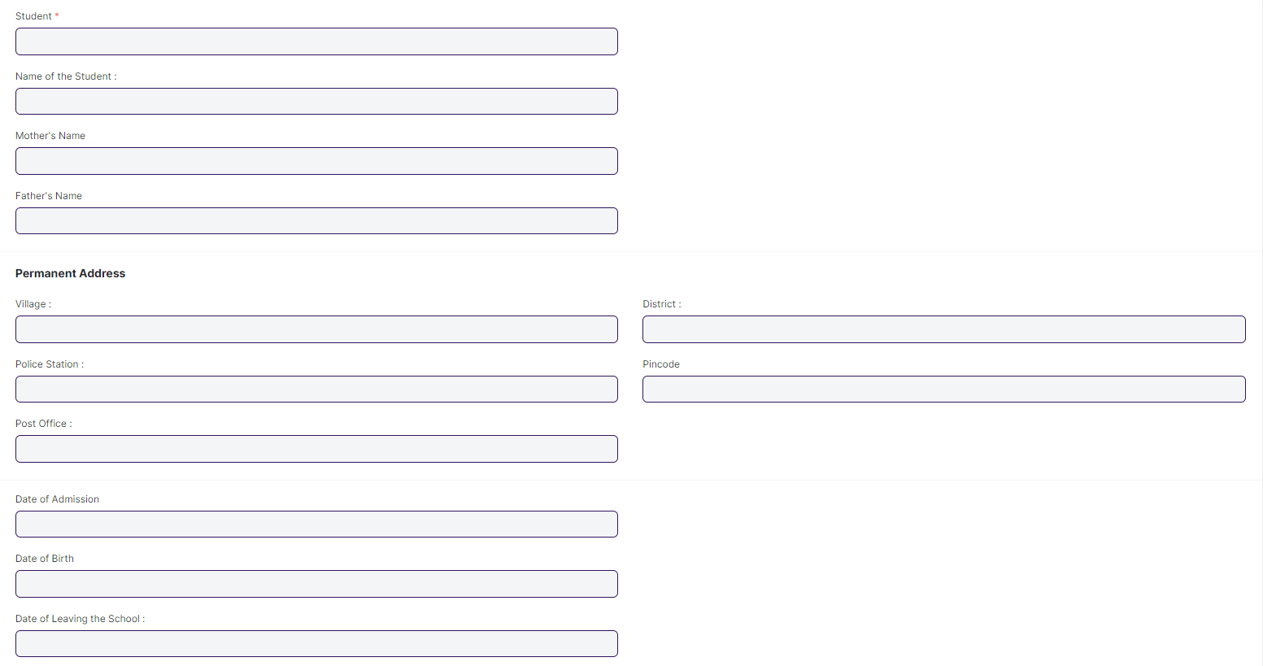

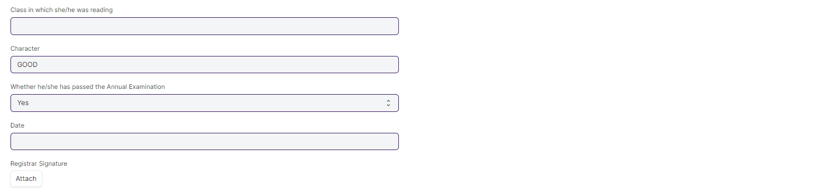

#### **Business Requirements:**

* No changes needed as discussed.

### **Provisional Certificate**

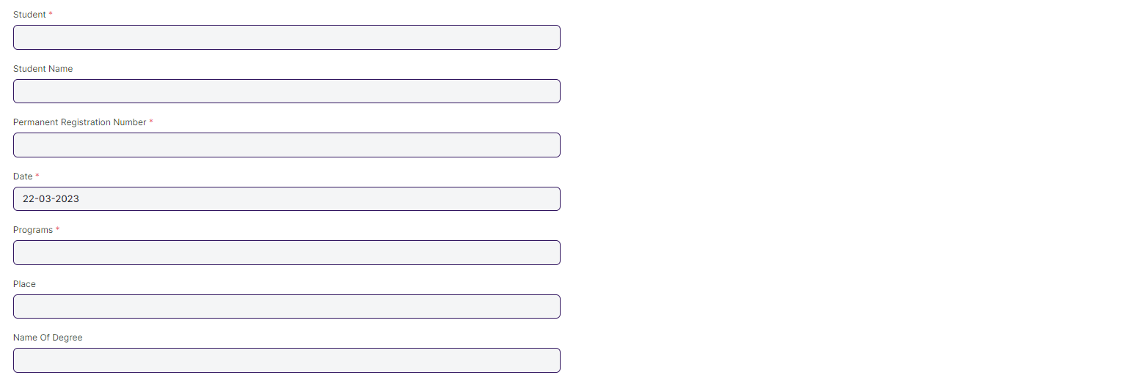

#### **Business Requirements:**

* No changes needed as discussed.

### **Migration Certificate**

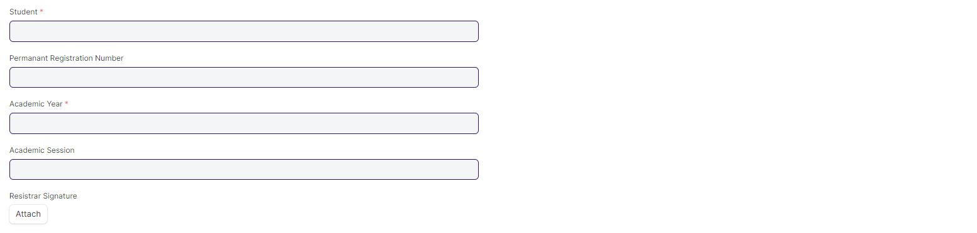

#### **Business Requirements:**

* No changes needed as discussed.

### **Conduct Certificate**

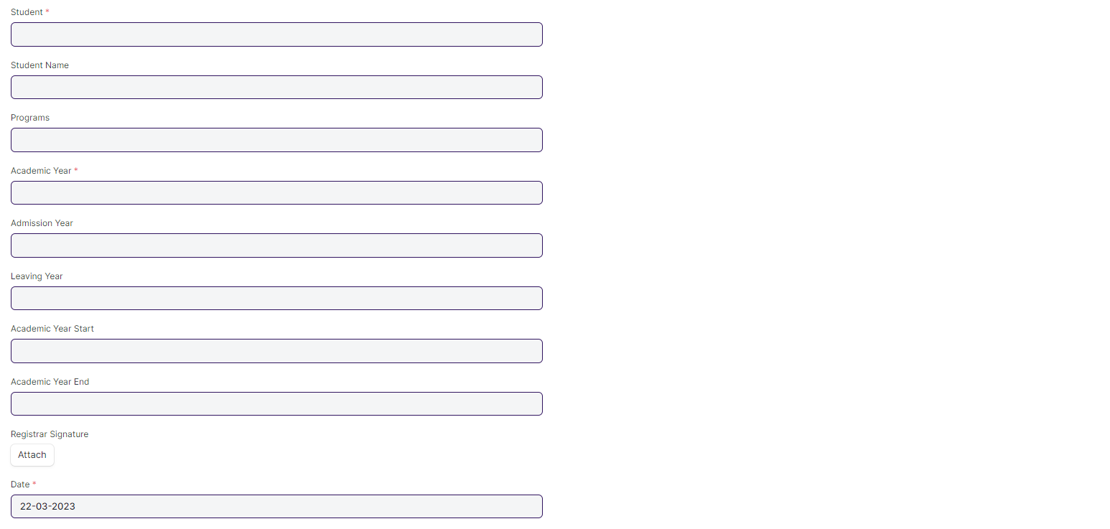

#### **Business Requirements:**

* No changes needed as discussed.

### **Cumulative Marksheet**

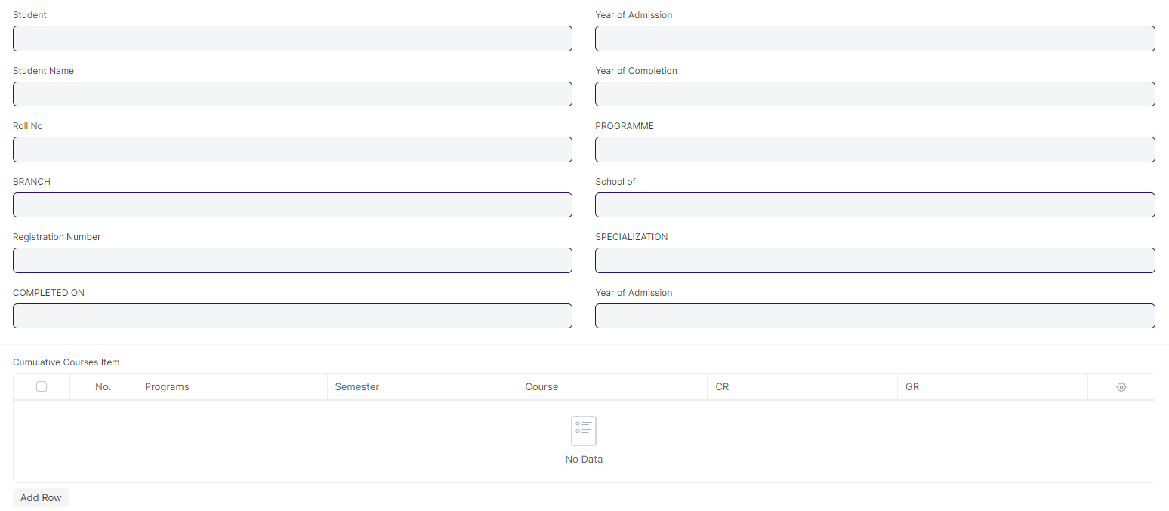

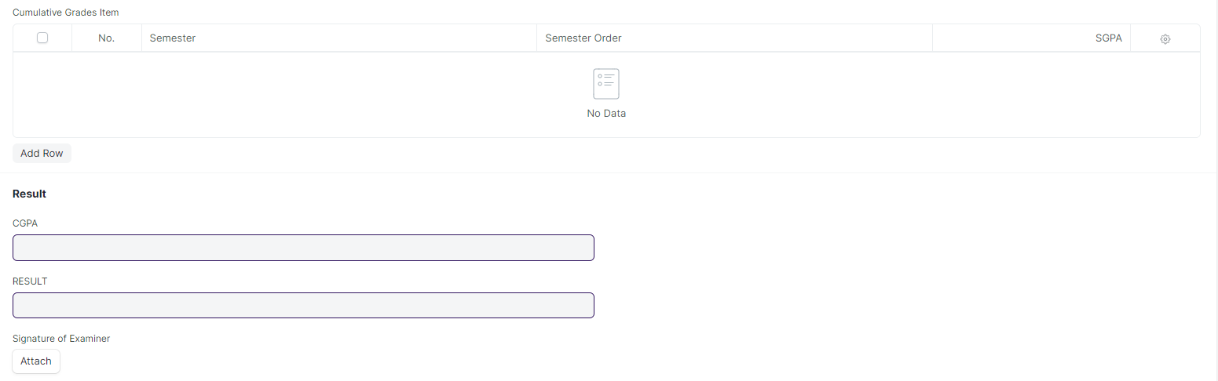

#### **Business Requirements:**

* Remove/Hide the CGPA, SGPA, and Credit features from the Cumulative Mark sheet and display the percentage and grade instead.

# **Hostel**

## **Masters**

### **18.1 Hostel Masters**

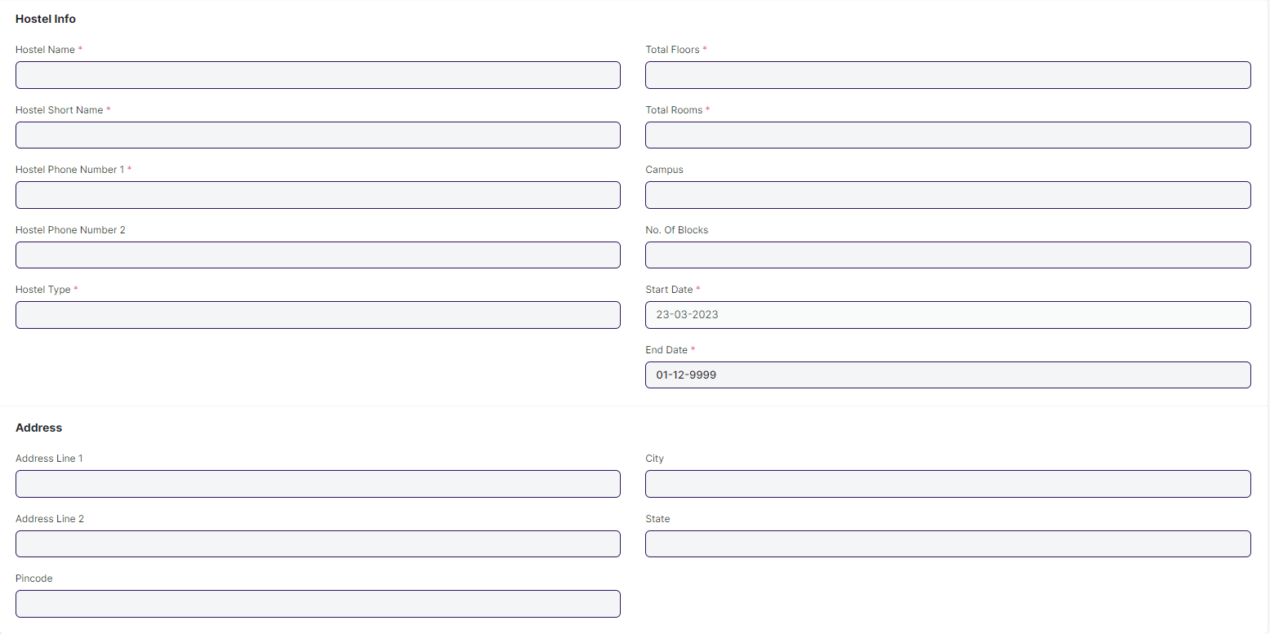

#### **Business Requirement:**

* No changes needed as discussed.

### **18.2 Room Masters**

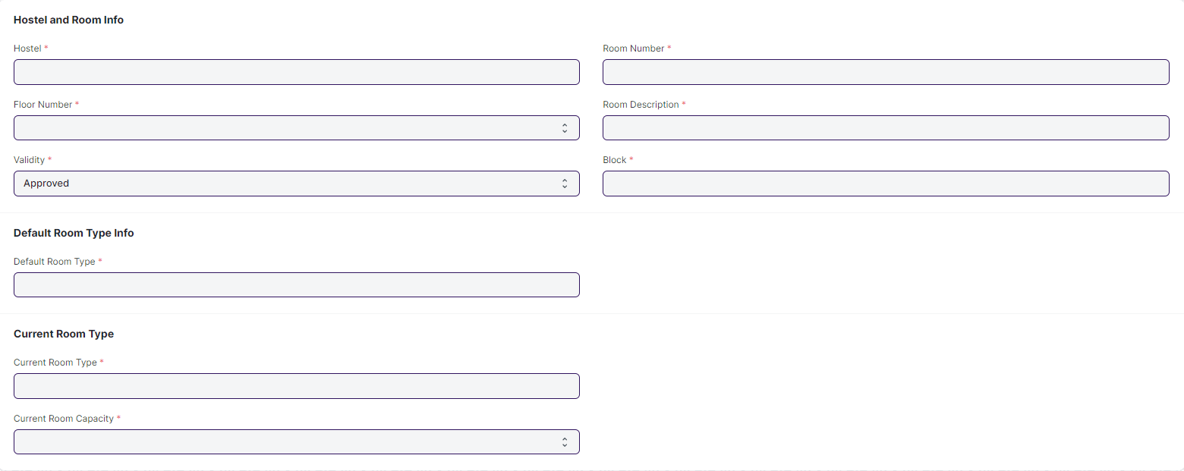

#### **Business Requirement:**

* No changes needed as discussed.

### **18.3 Hostel Type**



#### **Business Requirement:**

* No changes needed as discussed.

### **18.4 Room Type**

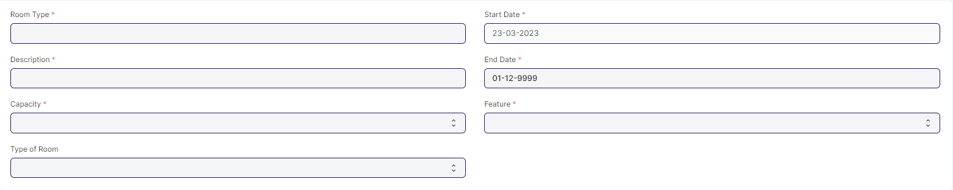

#### **Business Requirement:**

* No changes needed as discussed.

### **18.5 Room Description**

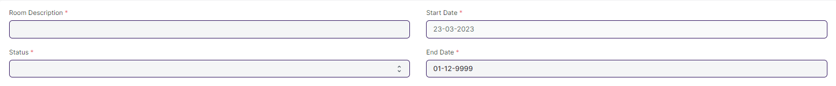

#### **Business Requirement:**

* No changes needed as discussed.

### **18.6 Employee Hostel Allotment**

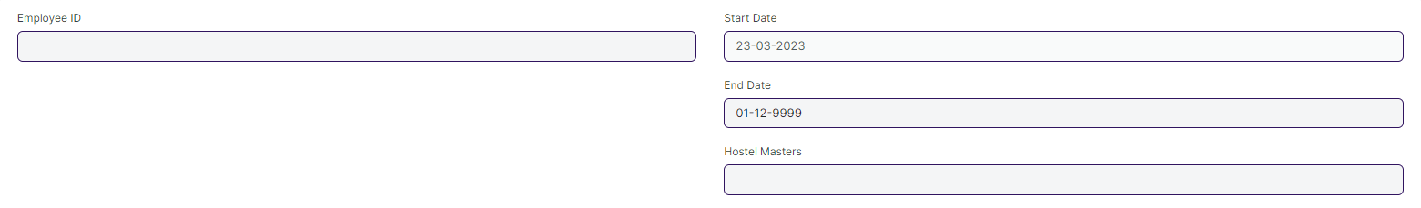

#### **Business Requirement:**

* No changes needed as discussed.

## **Disciplinary Committee Processes**

### **19.1 In-disciplinary Complaint Registration**

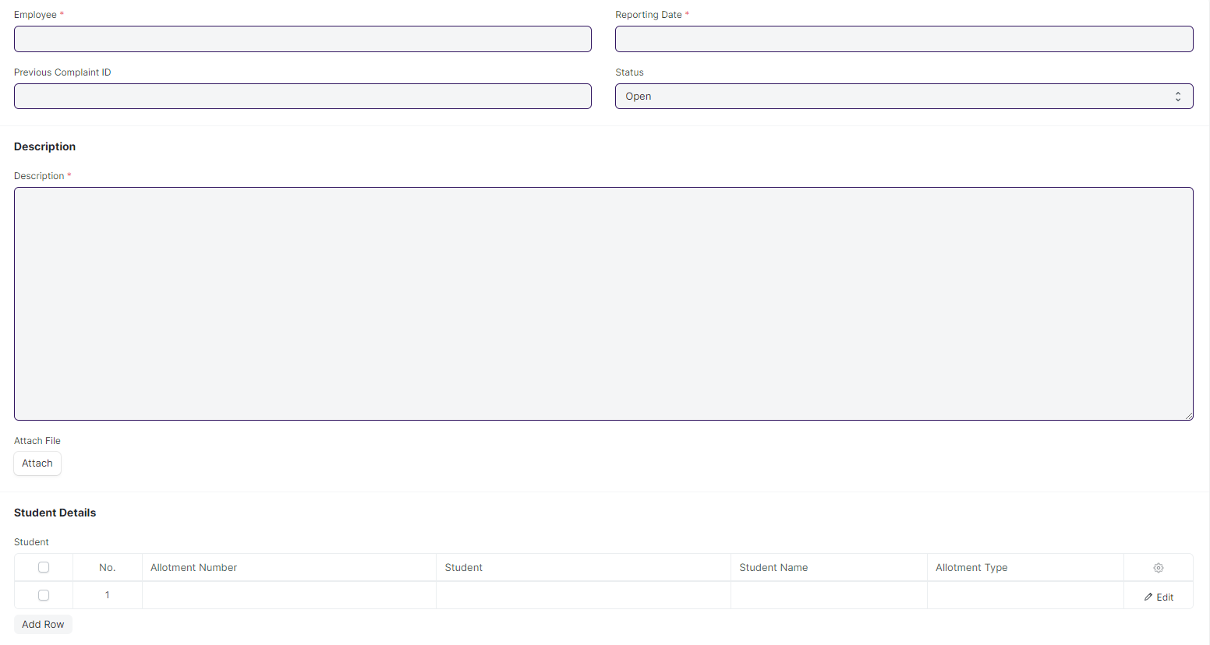

#### **Business Requirement:**

* No changes needed as discussed.

### **19.2 In-disciplinary Actions**

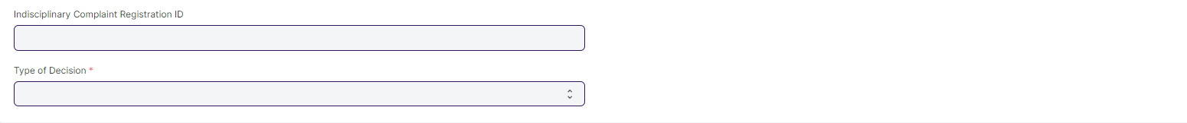

#### **Business Requirement:**

* No changes needed as discussed.

### **19.3 Disciplinary Committee Meeting**

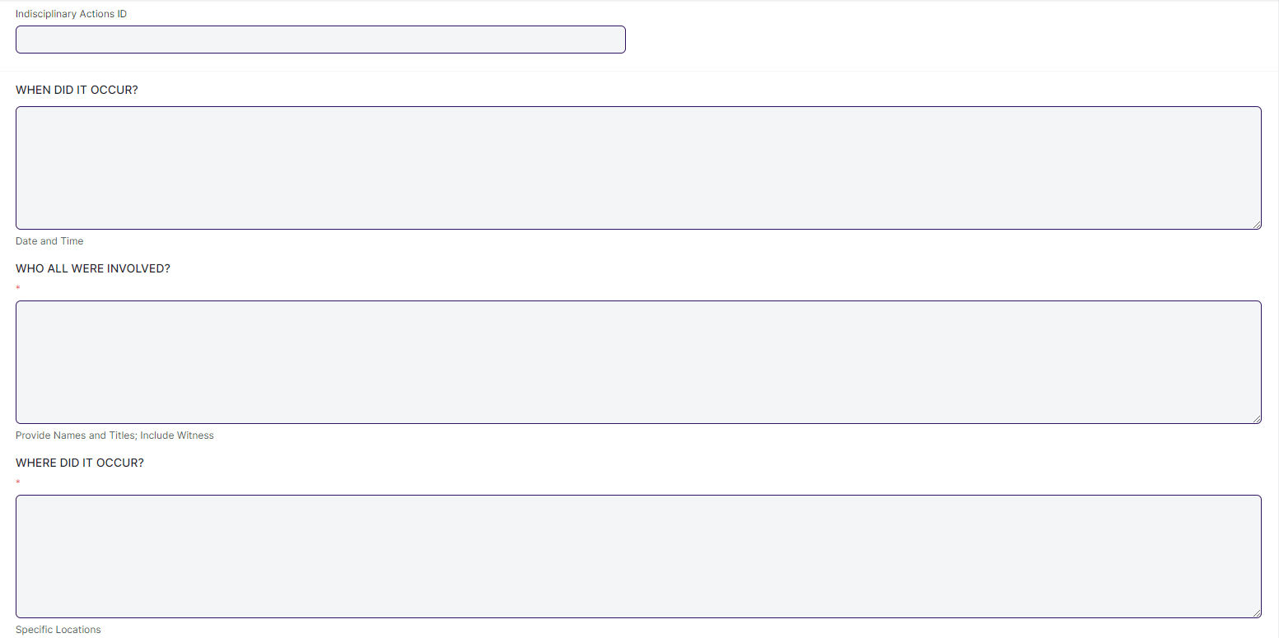

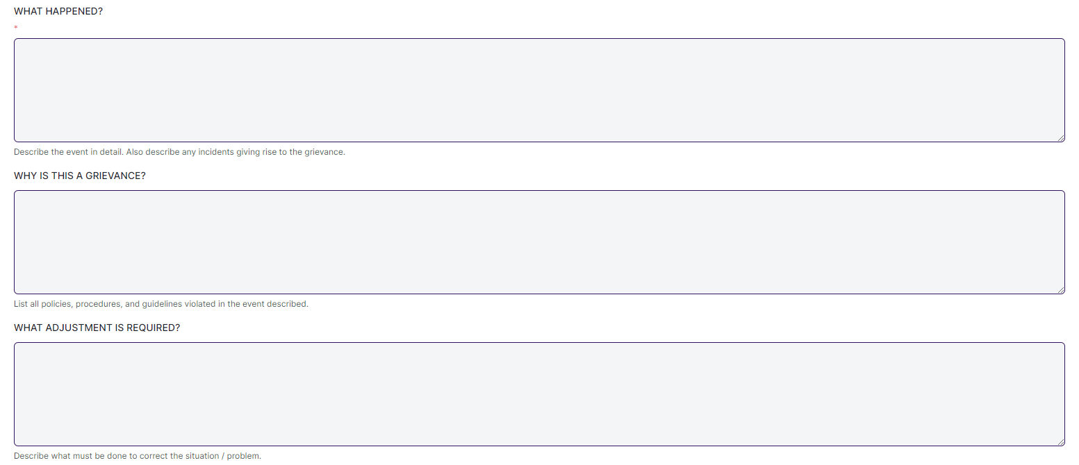

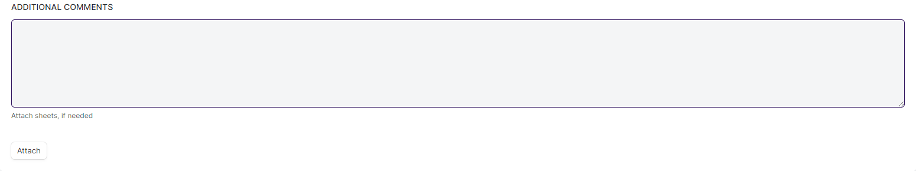

#### **Business Requirement:**

* No changes needed as discussed.

### **19.4 Withdrawal of Suspension**

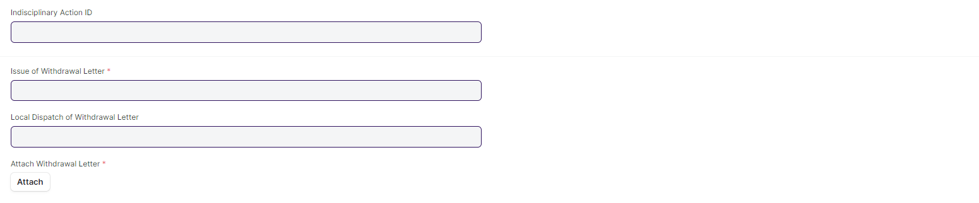

#### **Business Requirement:**

* No changes needed as discussed.

### **19.5 Hostel Suspension Room Change**

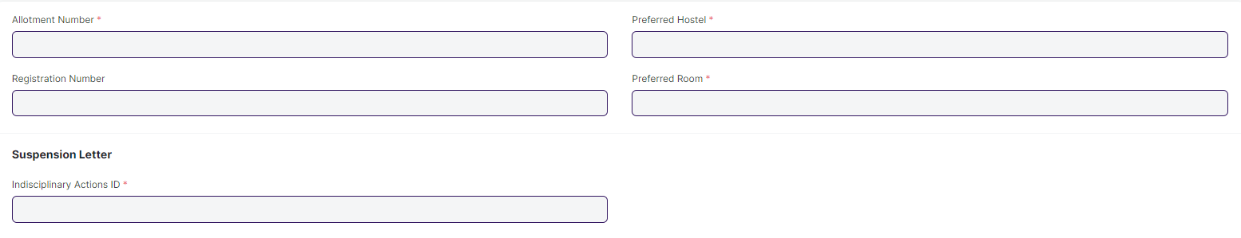

#### **Business Requirement:**

* No changes needed as discussed.

## **Student Admission & Essentials**

### **20.1 Student Hostel Admission**

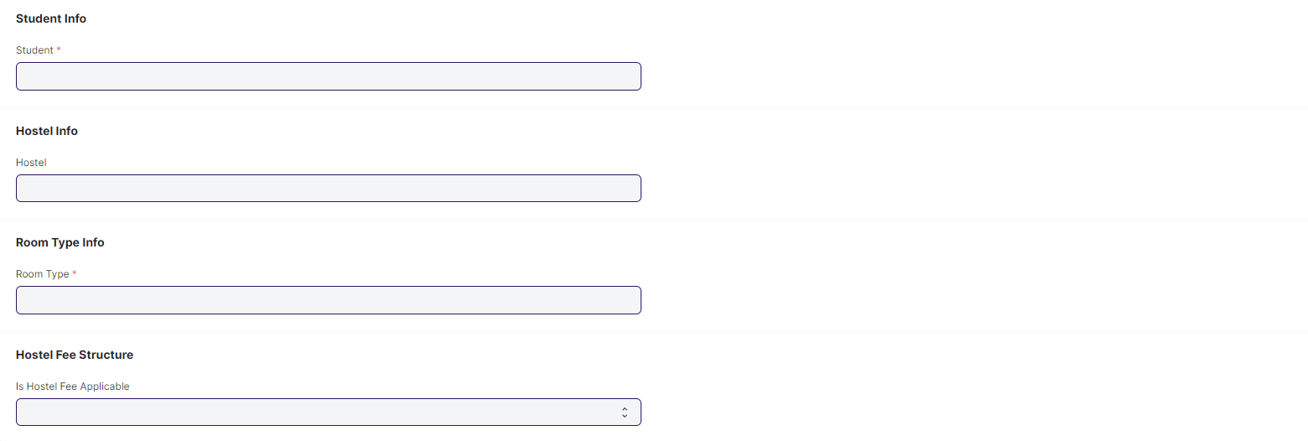**Business Requirement:**

* No changes needed as discussed.

### **20.2 Student Medical History**

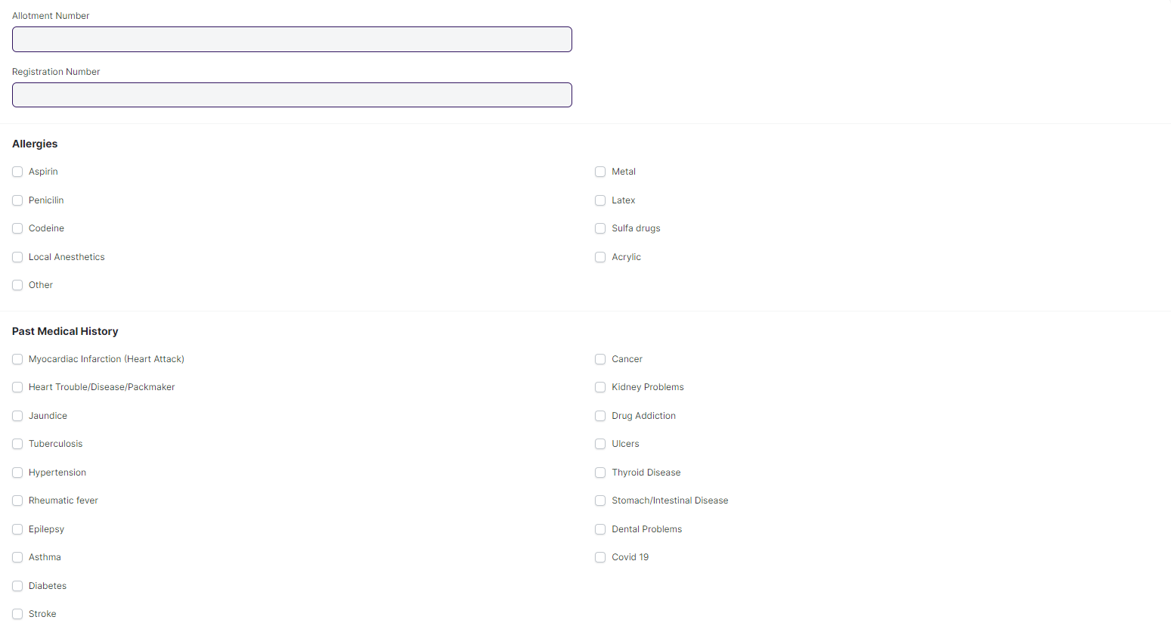

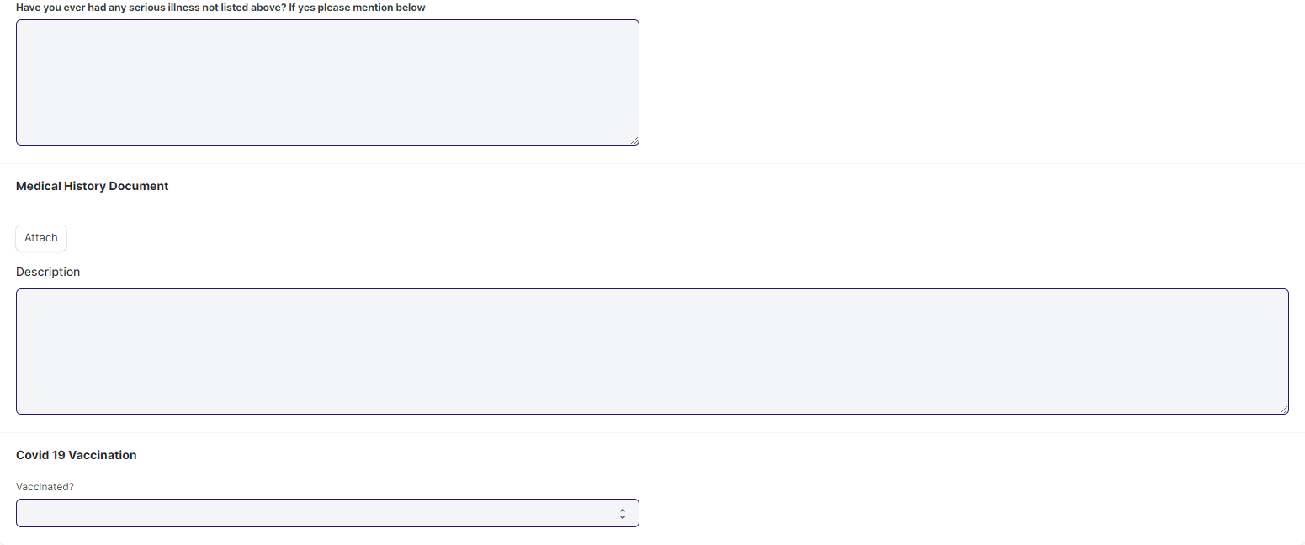

#### **Business Requirement:**

* No changes needed as discussed.

### **20.3 Student Leave Process**

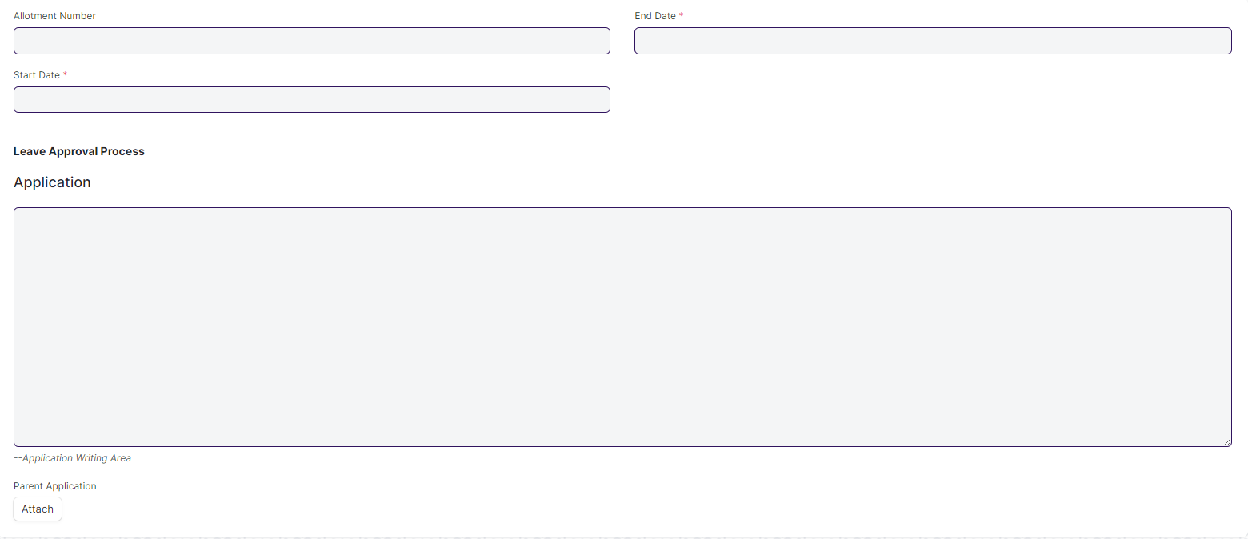

#### **Business Requirement:**

* No changes needed as discussed.

### **20.4 Material Distribution**

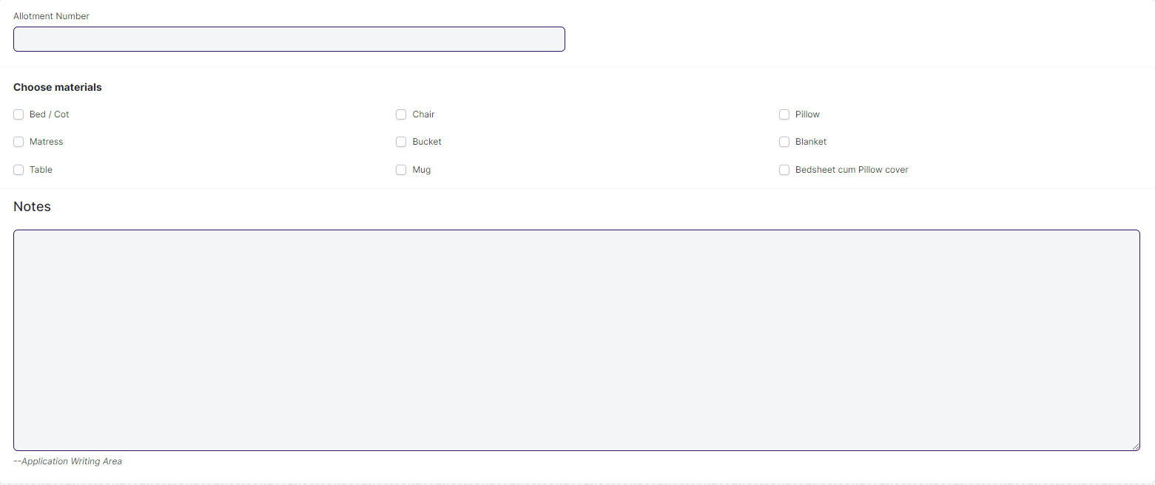

#### **Business Requirement:**

* No changes needed as discussed

## **Allotment & De-Allotment**

### **21.1 Room Allotment**

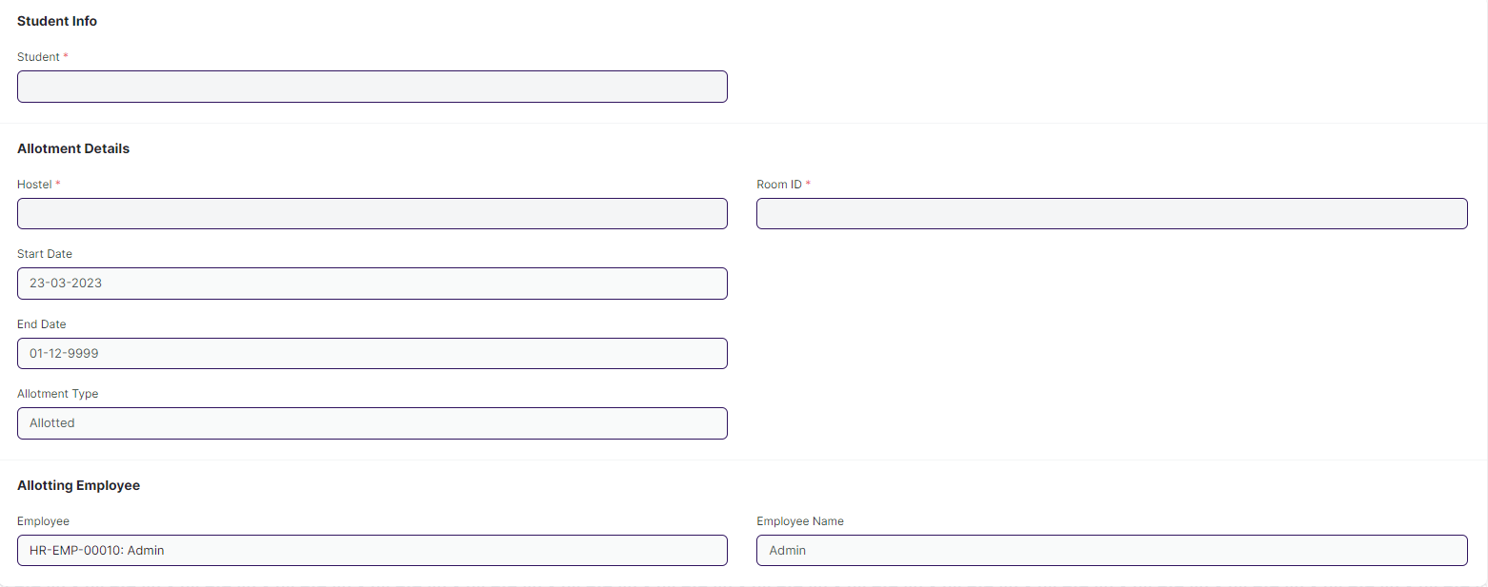

#### **Business Requirement:**

* No changes needed as discussed

### **21.2 Deallotment Process**

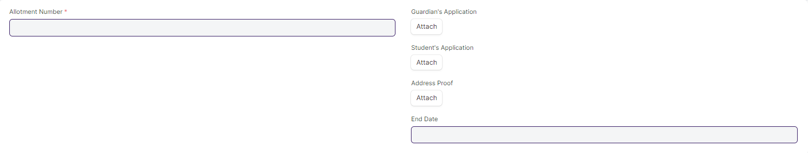

#### **Business Requirement:**

* No changes needed as discussed

### **21.3 Room Change**

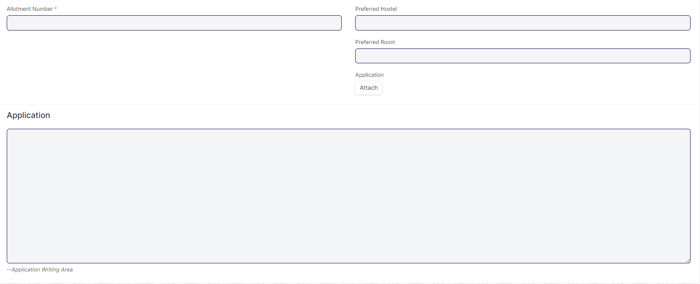

#### **Business Requirement:**

* No changes needed as discussed

### **21.4 Death Deallotment**

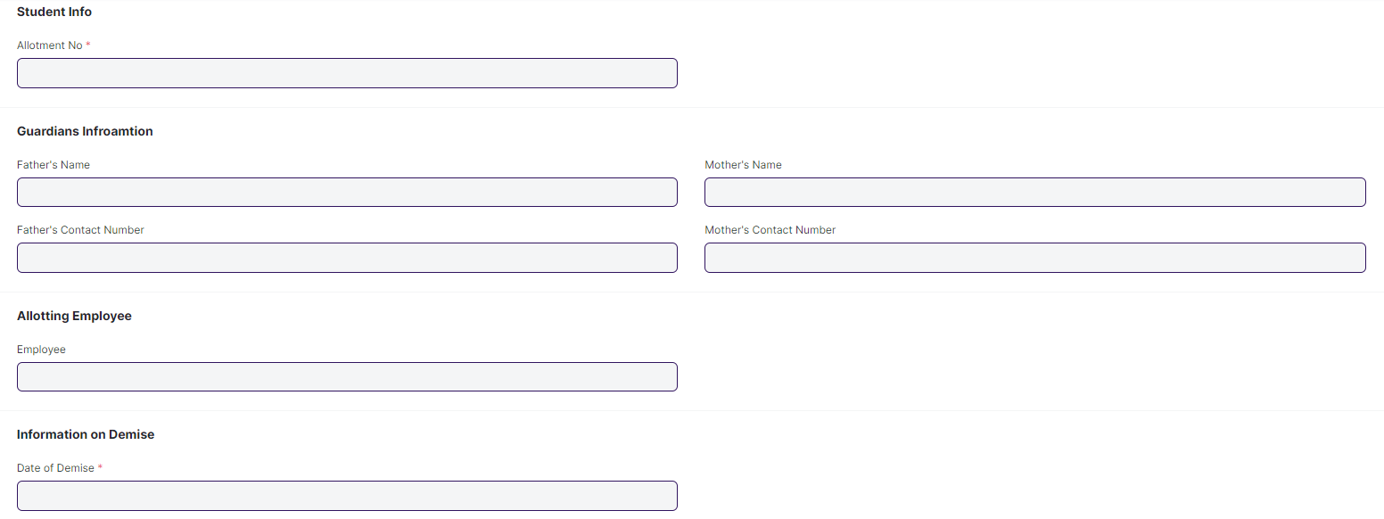

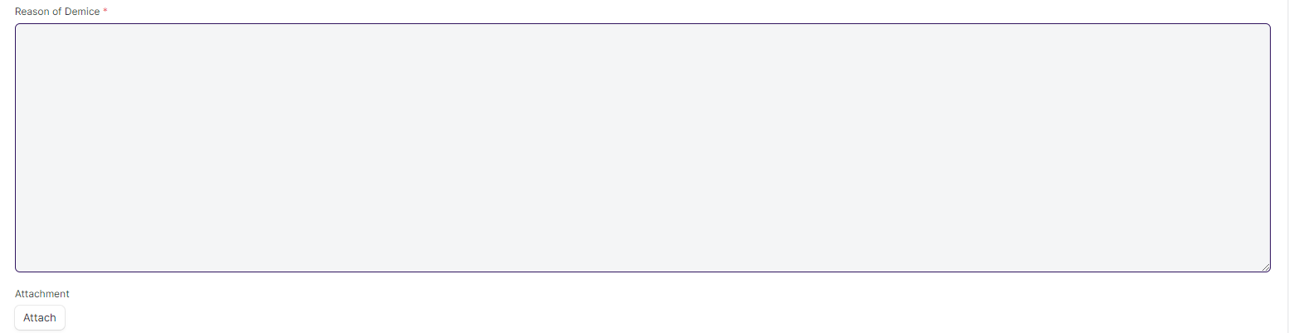

#### **Business Requirement:**

* No changes needed as discussed

### **21.5 Long Leave**

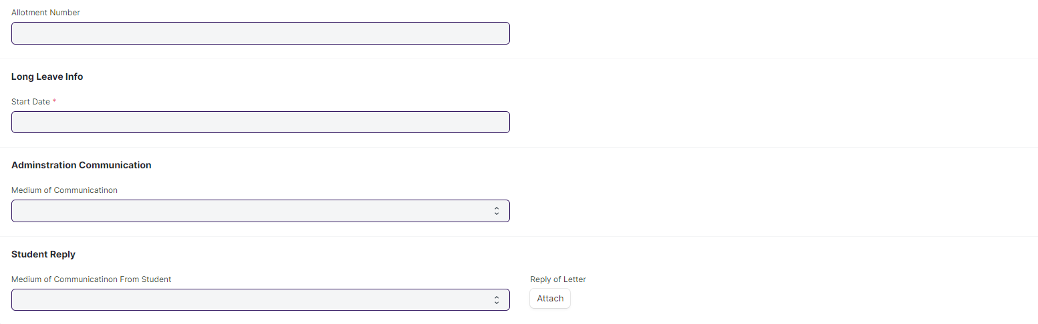

#### **Business Requirement:**

* No changes needed as discussed

### **21.6 Inter or Intra Hostel Change**

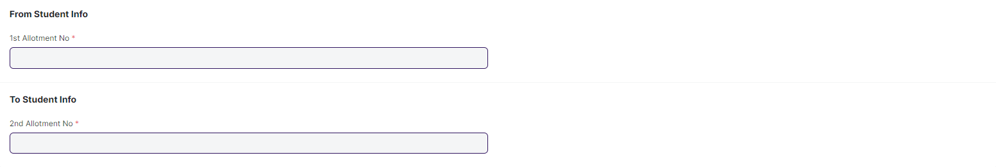

#### **Business Requirement:**

* No changes needed as discussed

## **Hostel Fees**

### **Fee Structure Hostel**

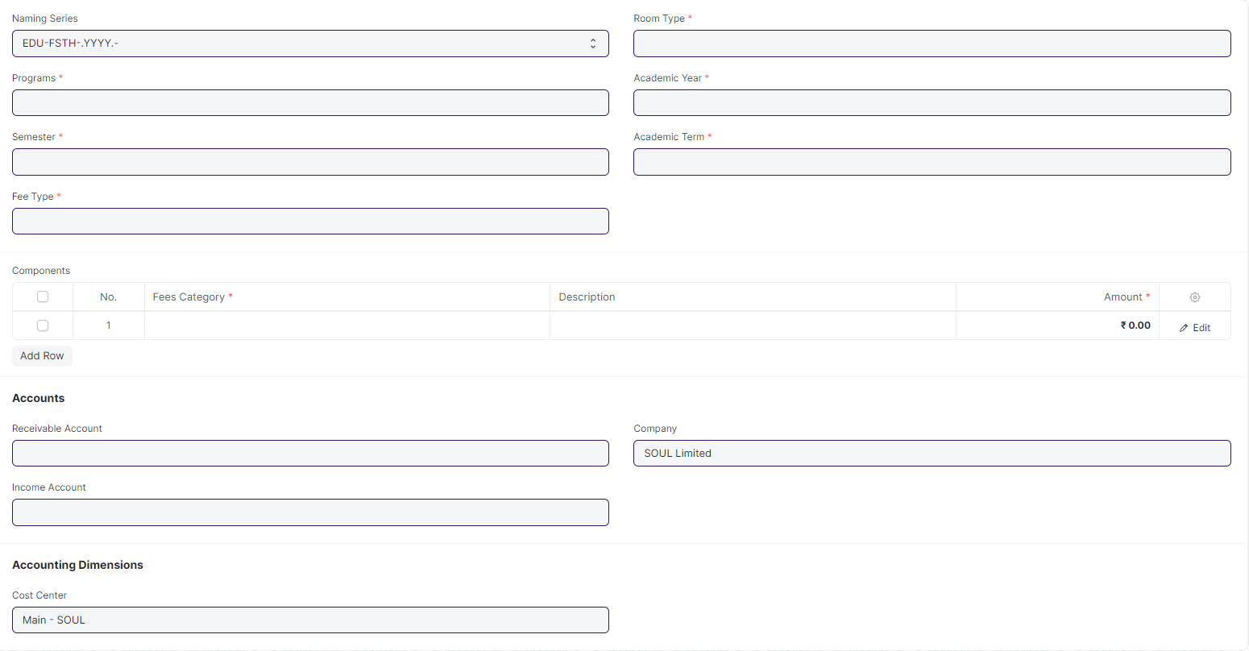

#### **Business Requirement:**

* No changes needed as discussed

### **Hostel Fee Schedule**

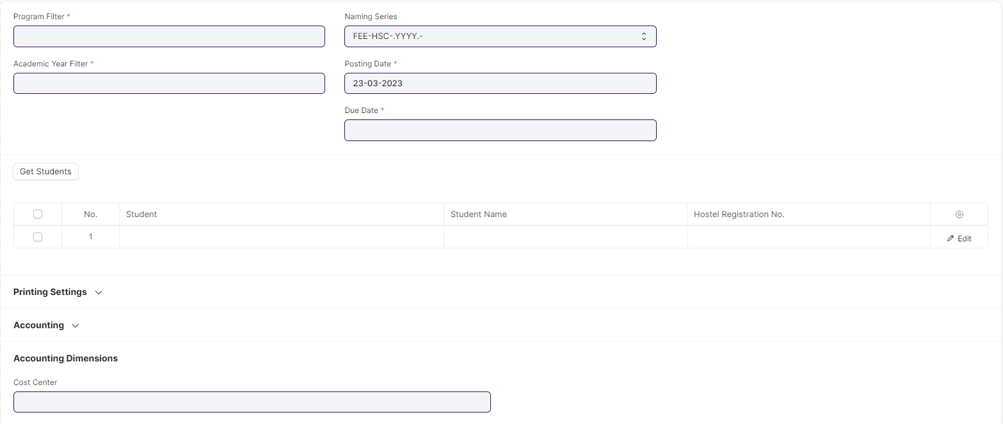

#### **Business Requirement:**

* No changes needed as discussed

### **Hostel Fees**

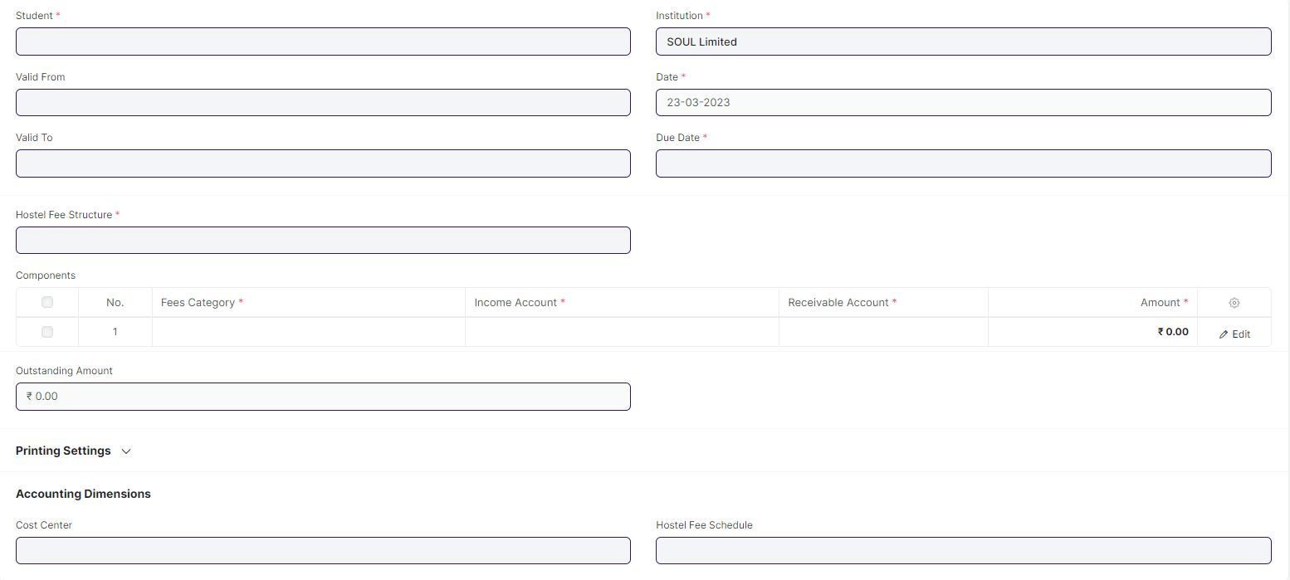

#### **Business Requirement:**

* No changes needed as discussed

## **Inward Suspension Letters**

### **Inward Suspension Letter**

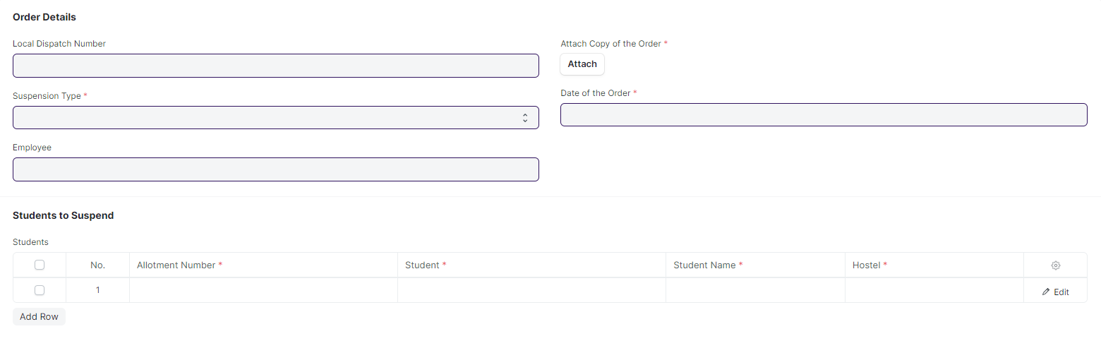

#### **Business Requirement:**

* No changes needed as discussed

### **Withdrawal of Inward Suspension Letter**



#### **Business Requirement:**

* No changes needed as discussed

## **Attendance**

### **Hostel Attendance**

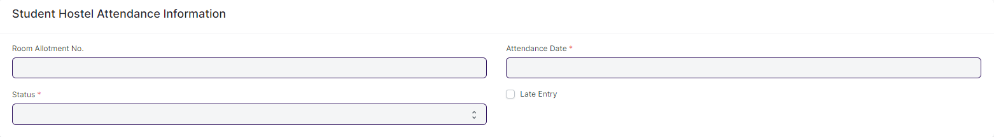

#### **Business Requirement:**

* No changes needed as discussed

### **Hostel Attendance Tool**

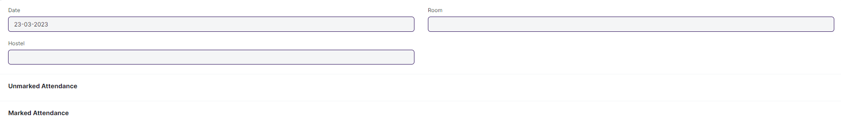

#### **Business Requirement:**

* No changes needed as discussed

## **Hostel Clearance**

### **Hostel Clearance**

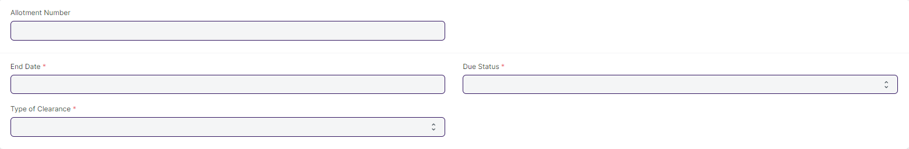

#### **Business Requirement:**

* No changes needed as discussed